Betül Güner

200709001

Ataturk University

Computer Engineering

2023-2024 Education Year R Programming Course Term Project Report

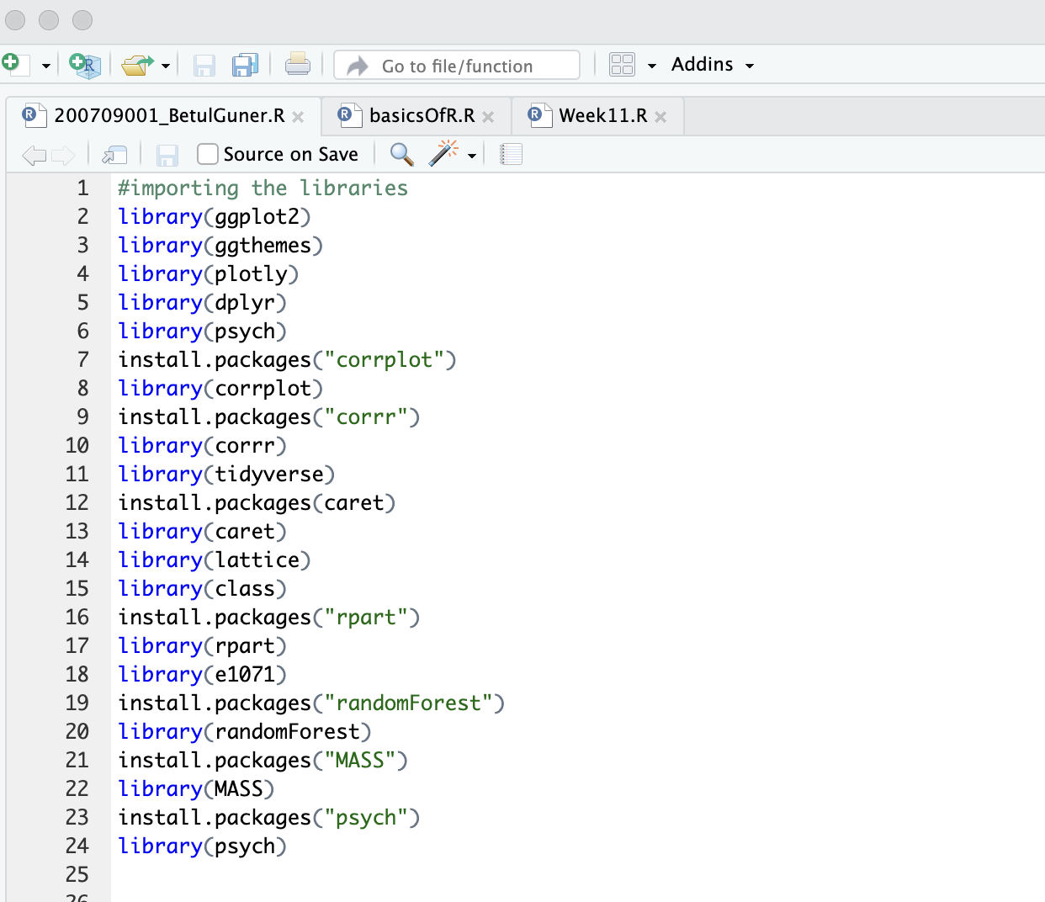

Firstly, libraries are installed and imported.

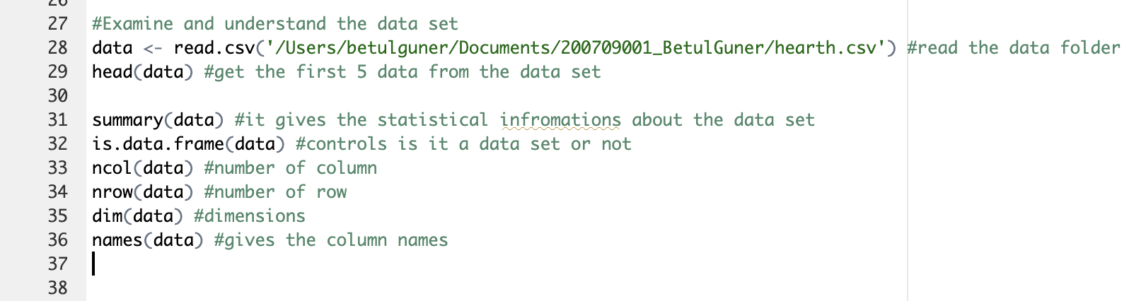

Observe the data set’ features.

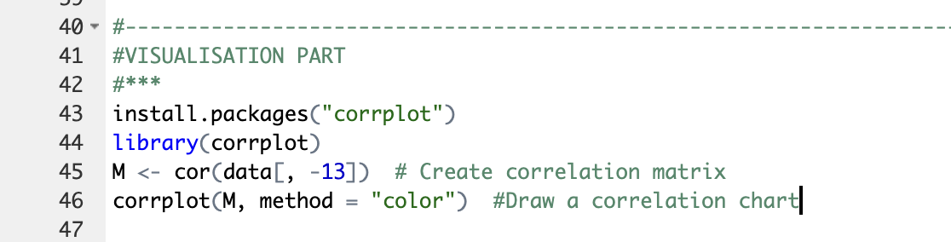

Visualization part.

Result of these code is:

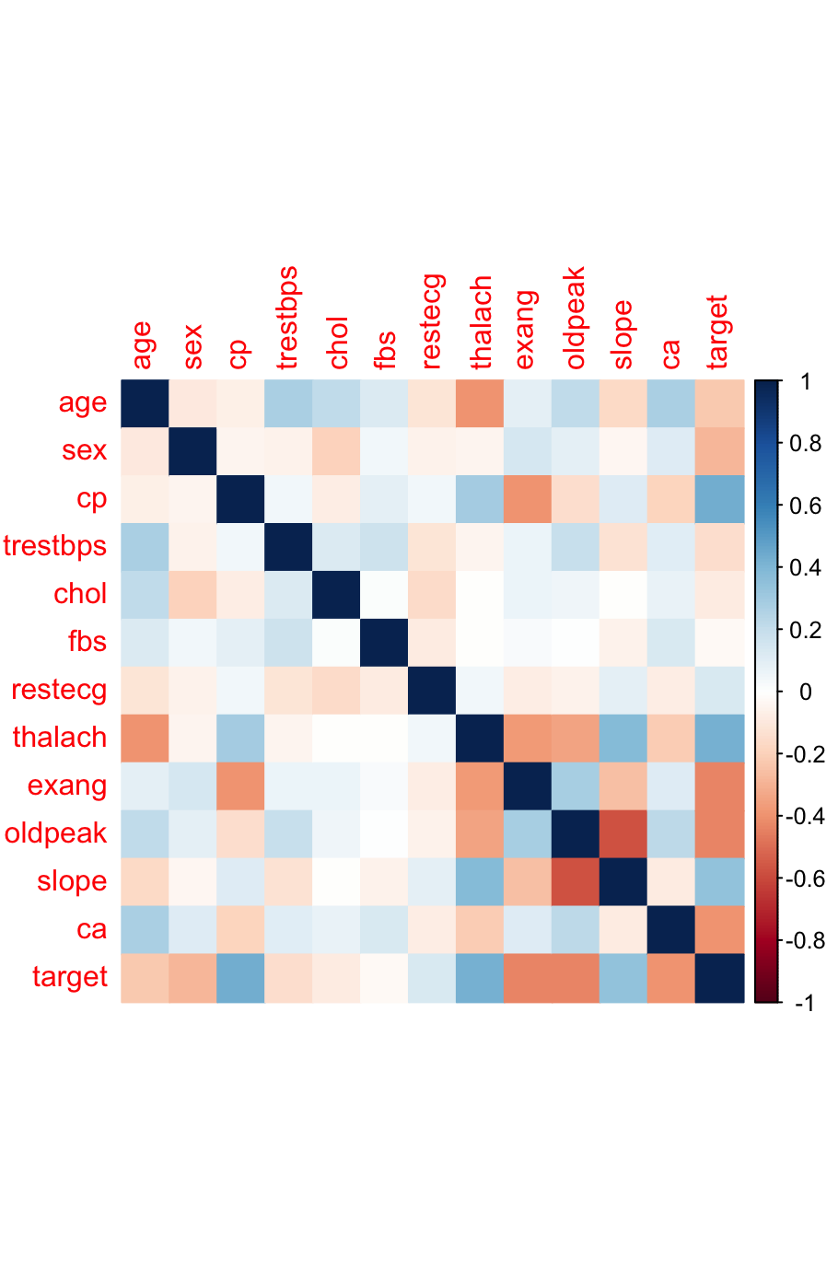

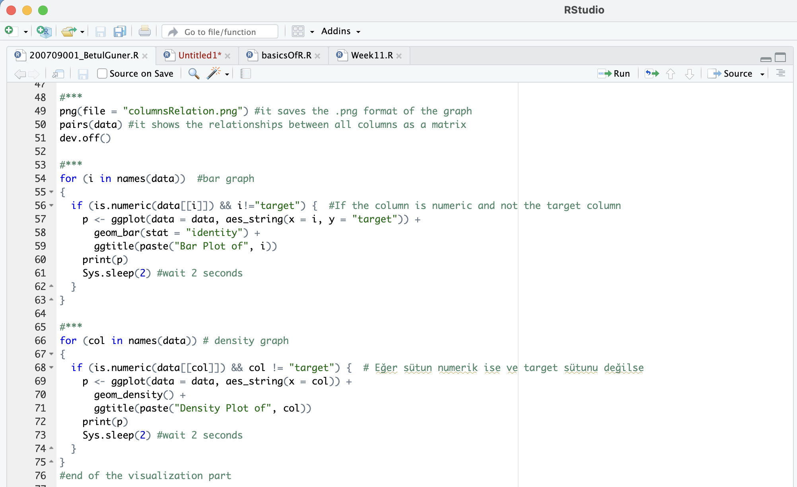

Visualization part(cont.)

pairs(data) -> It shows all the columns relations between each other.

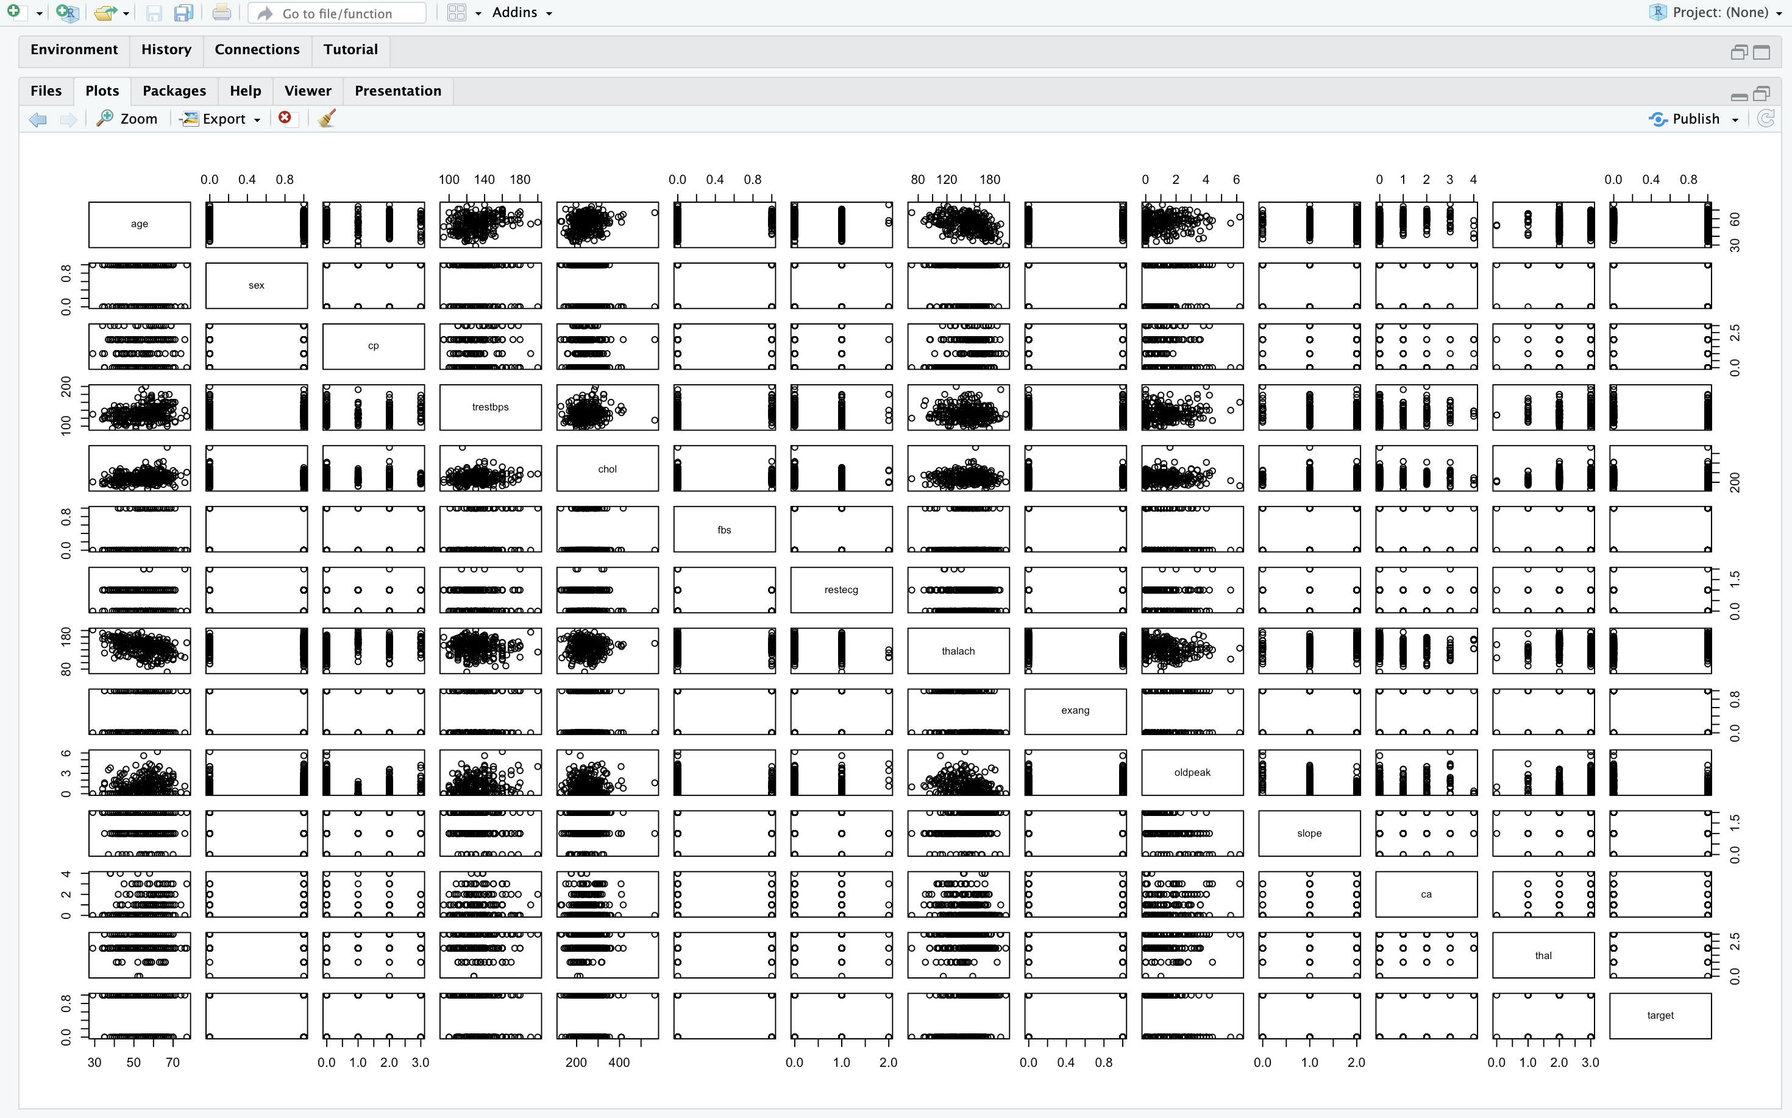

2 for loops show the all columns visualization with waiting 2 seconds for each graph.

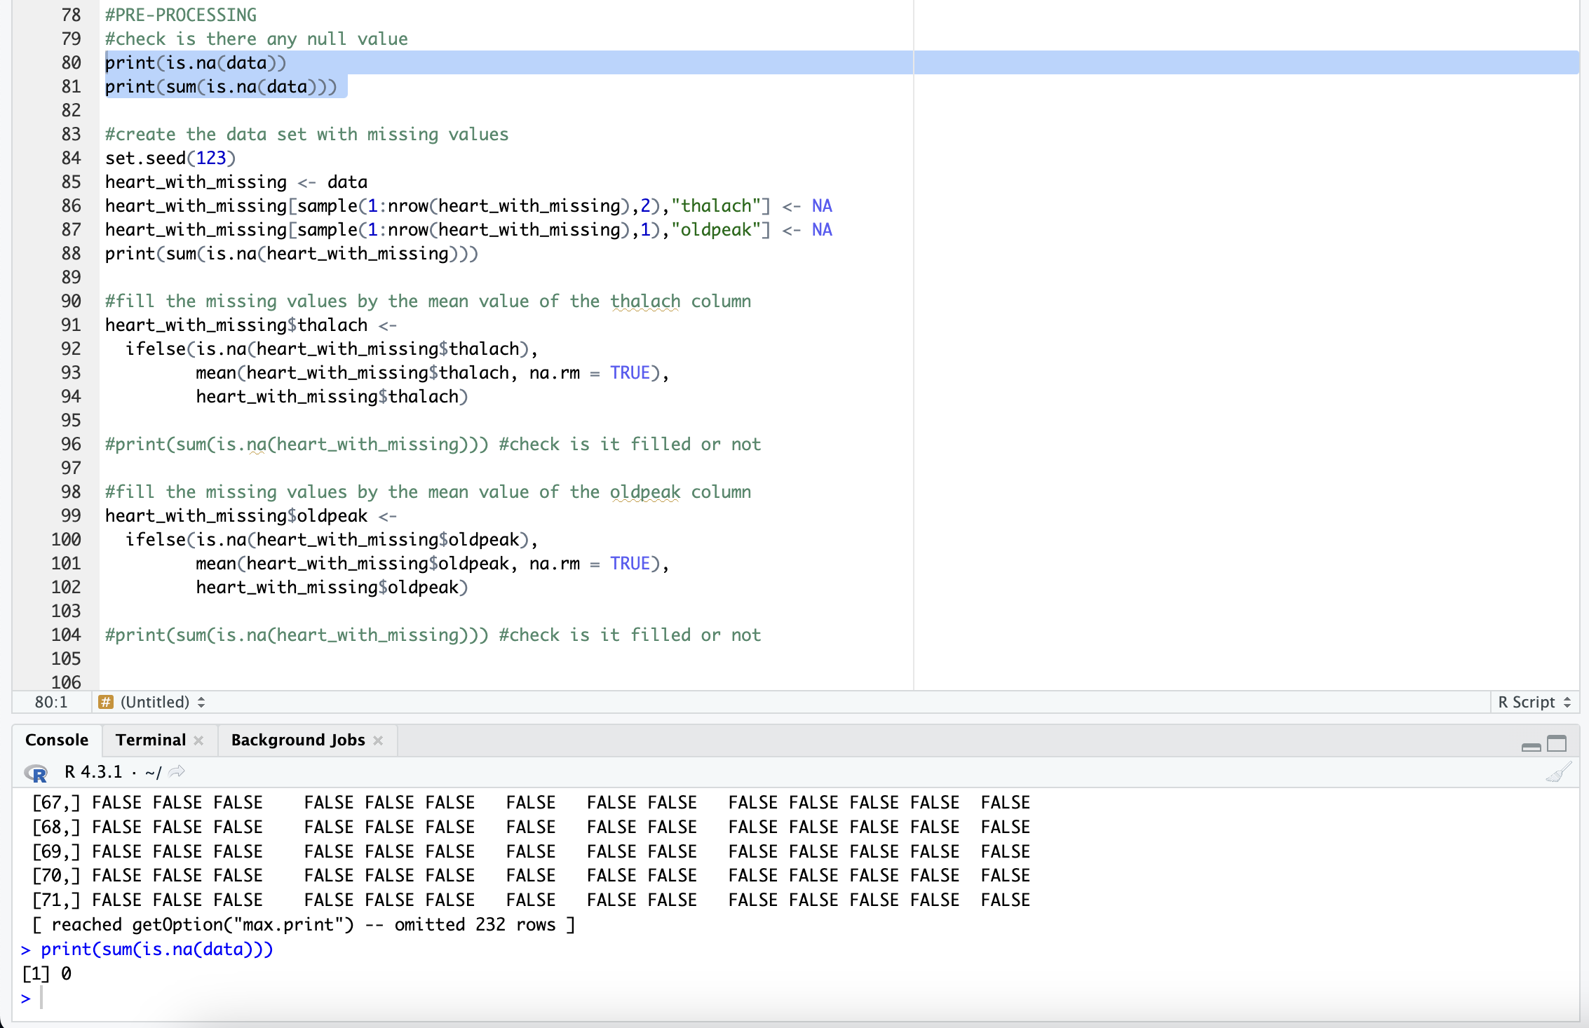

At this step, I made the pre-processing processes. Checked is there any null value or not? There was not any null value, so I create a new data set which has null values. Then, fill the null values with the that column’s average. Finally, checks is there any null value or not, and the pre-processing step is ended.

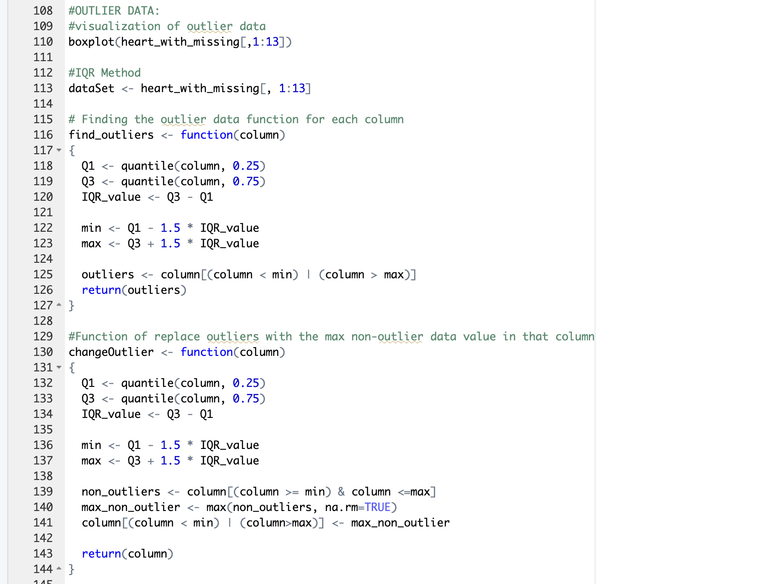

This step is finding the outlier data. Firstly, I visualize the data set of outlier data:

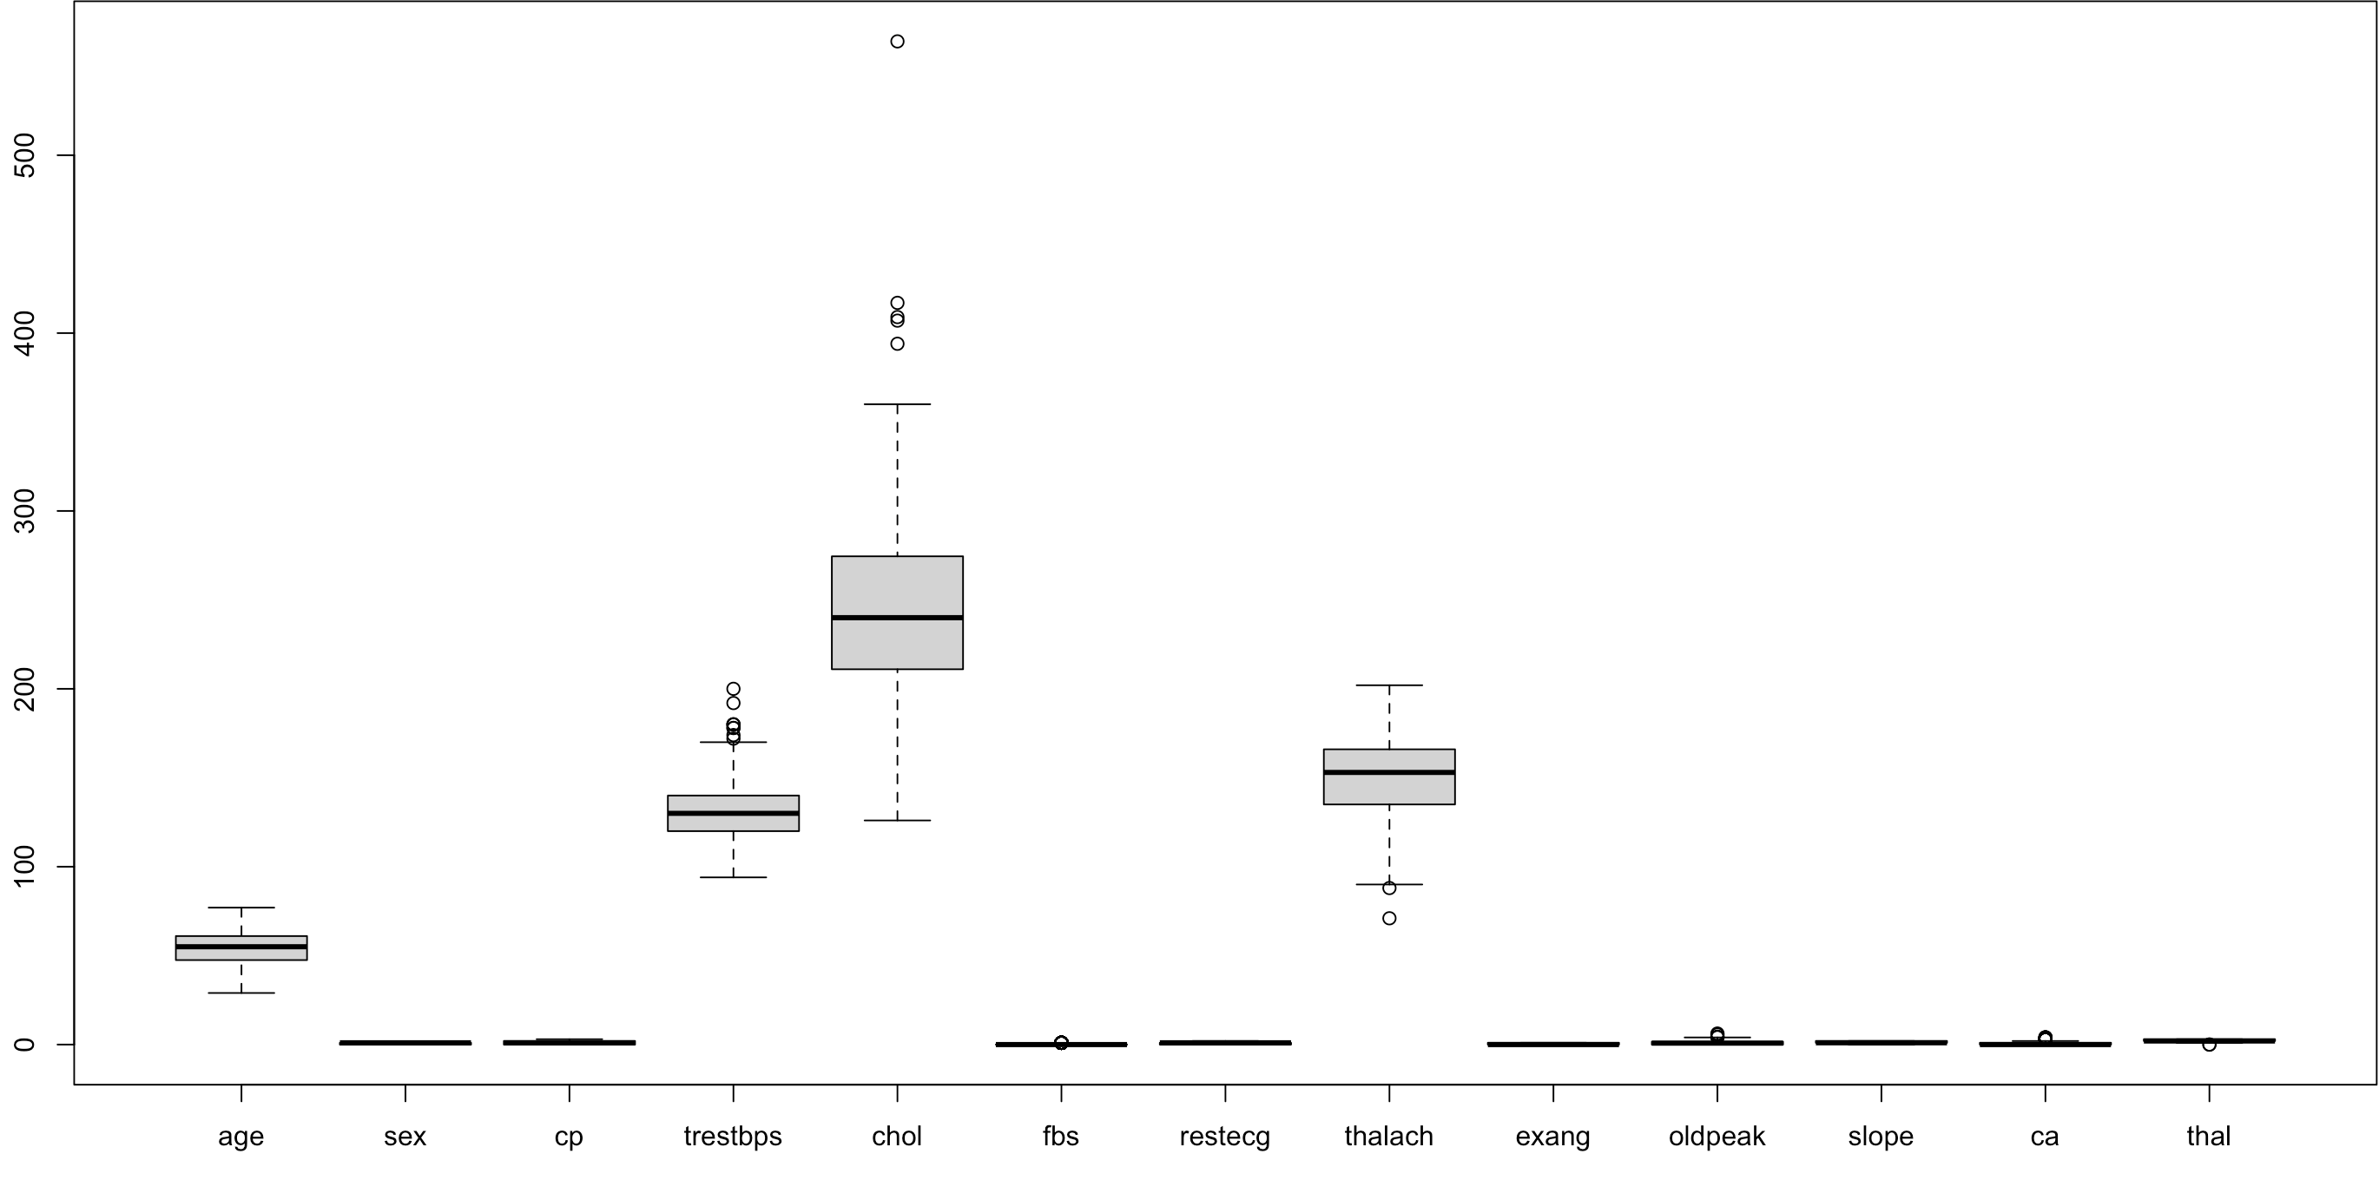

Then, find the outlier data with the IQR Method through a function. Finally, I replaced the outlier data with the maximum non-outlier data of each column with the help of the function that I wrote(changeOutlier()).

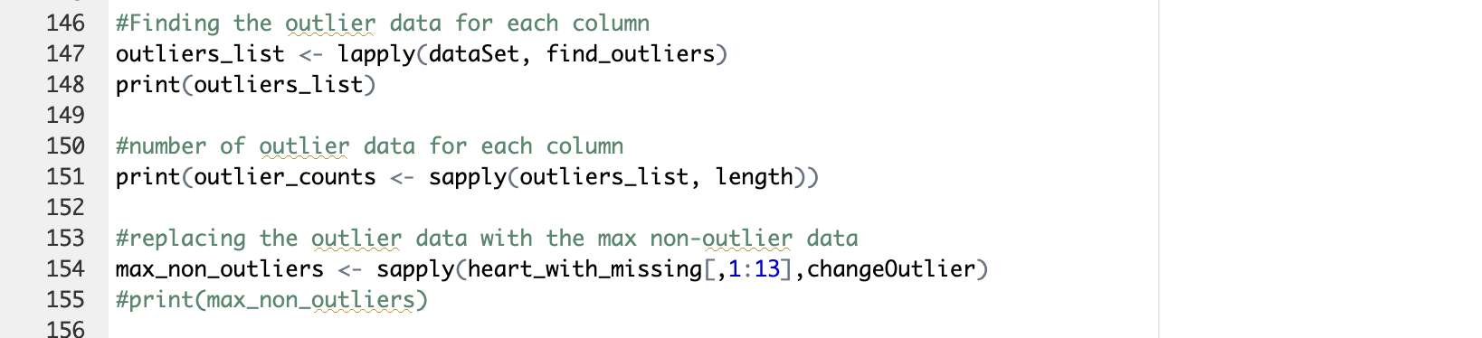

After calling the function checks is there any outlier value.

Now I applied the 6 types (KNN, Logistic Regression, Decision Tree, SVM, Gaussian Naïve Bayes,) classification methods on the data set. Find the accuracy, sensitivity, specificity, F1-Score, and confusion matrices of each classification method. Then, I visualized the classification results. I applied all these steps for all the classification types.

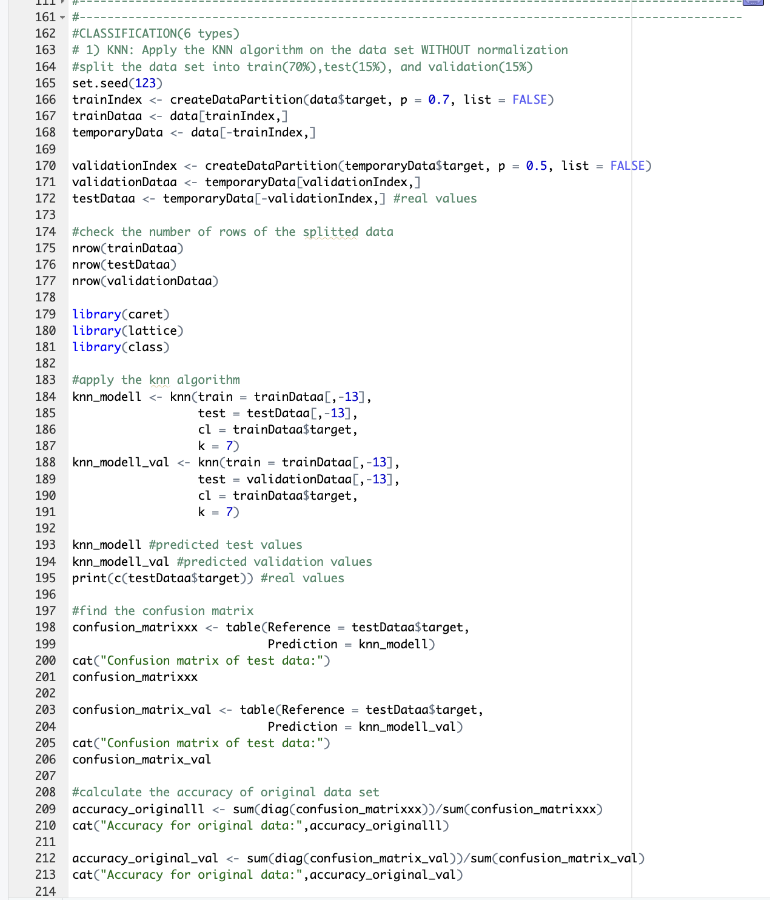

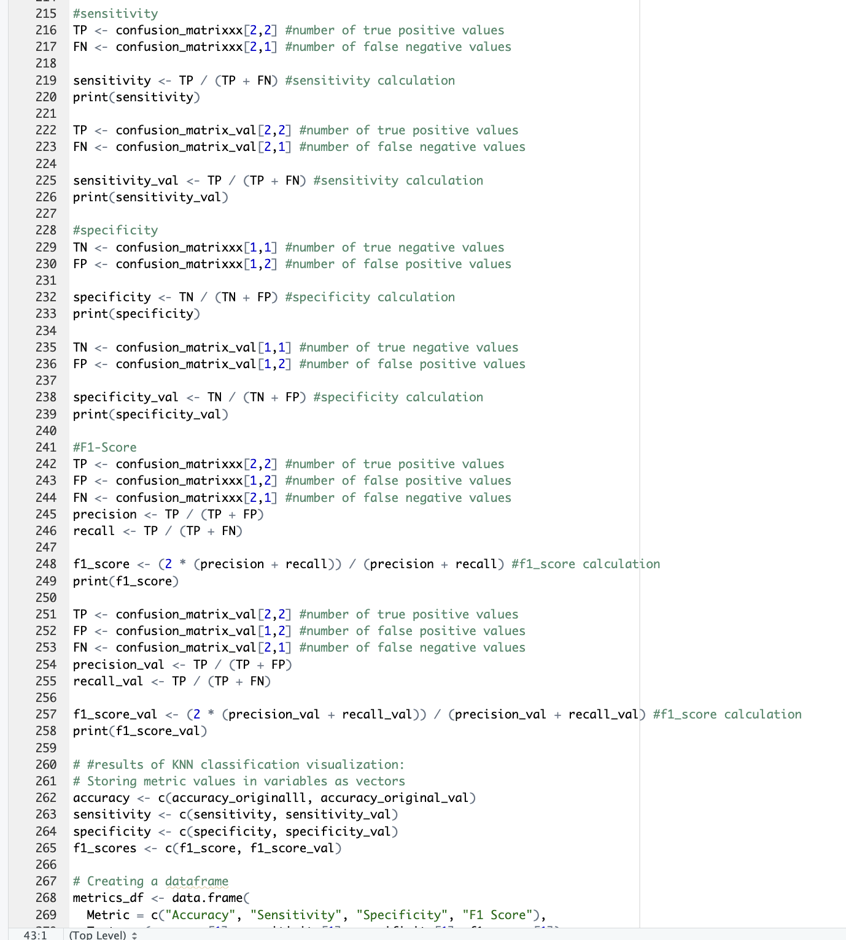

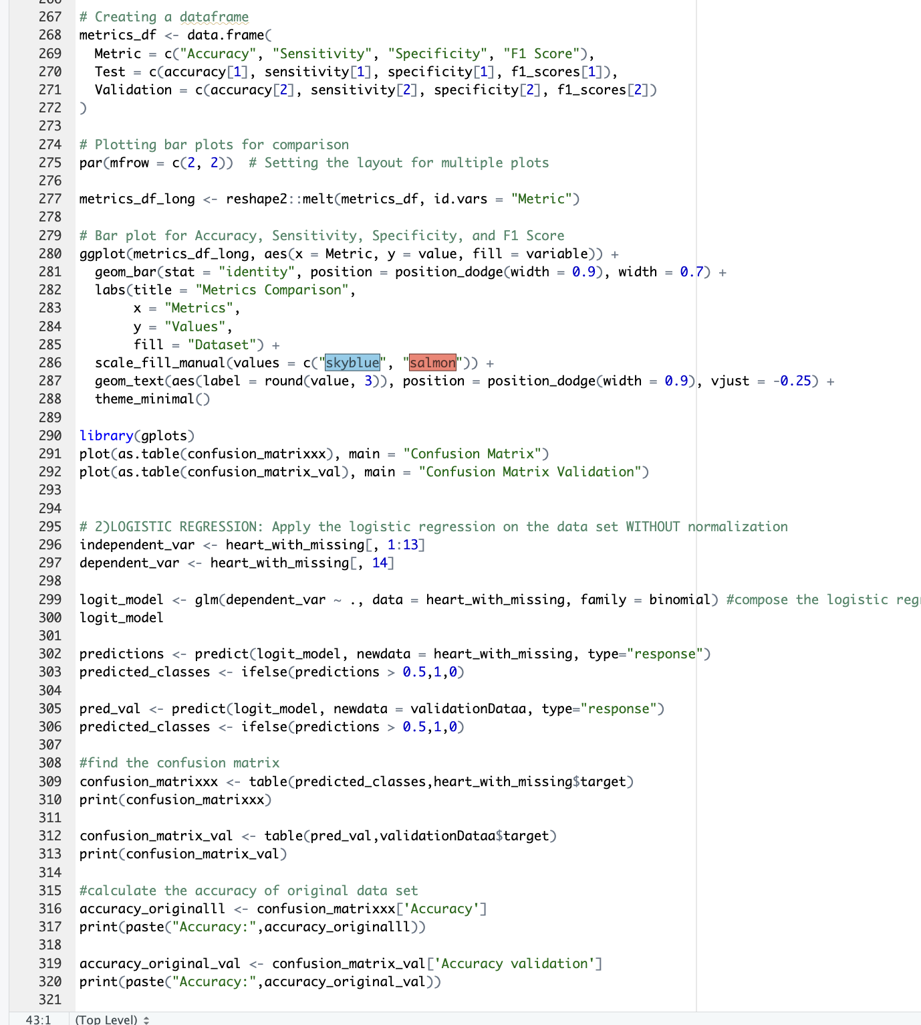

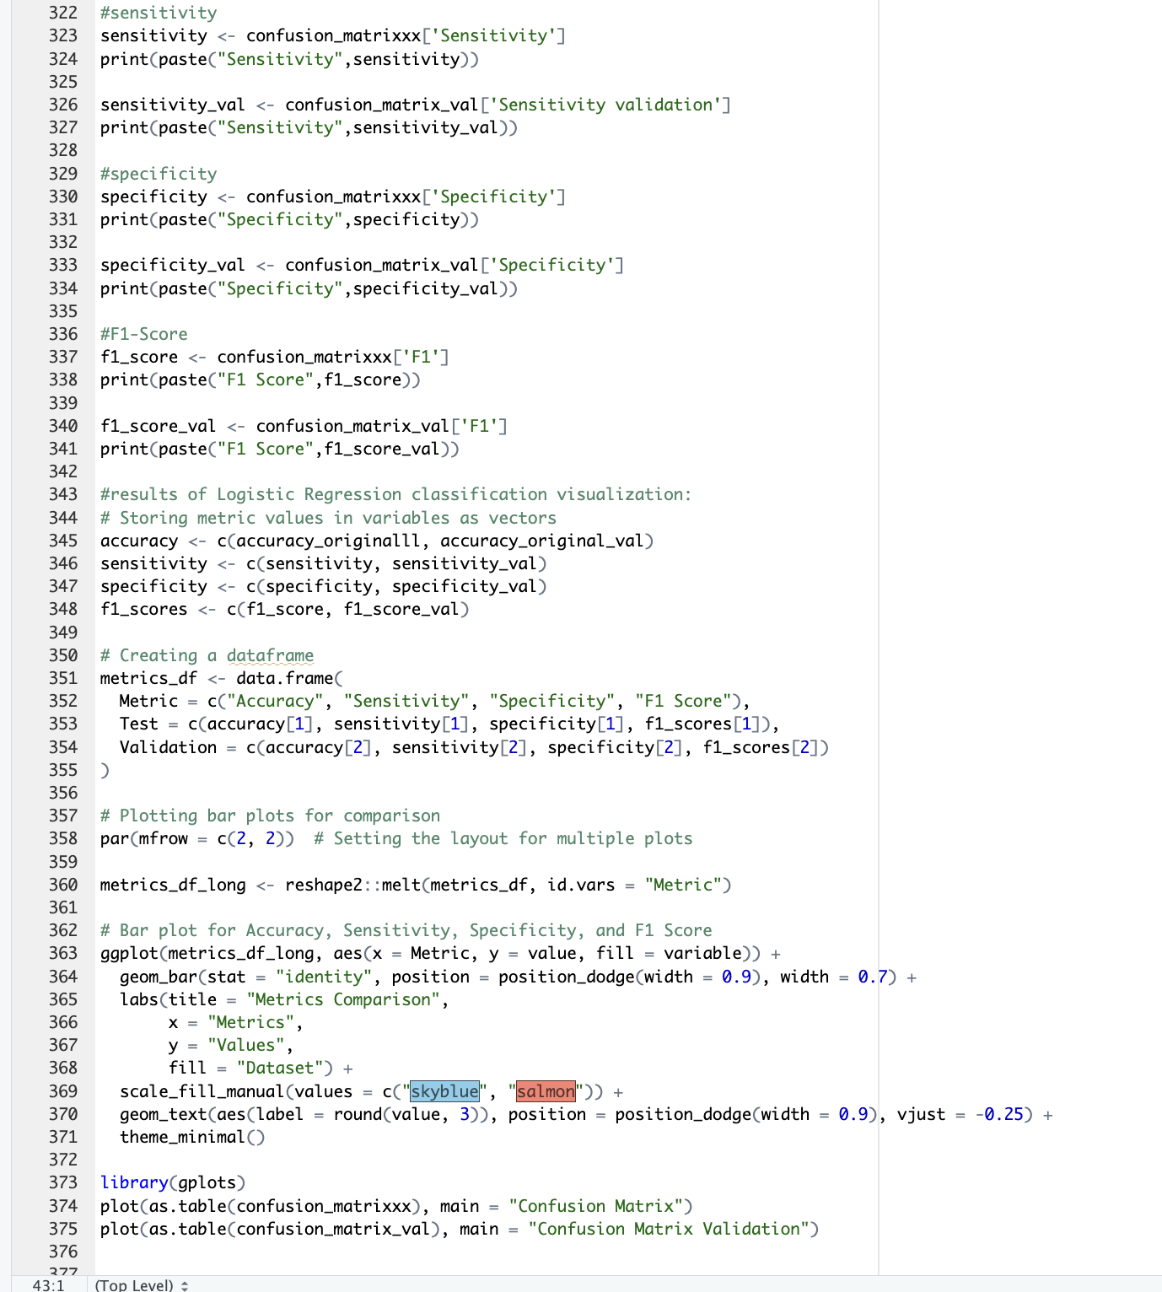

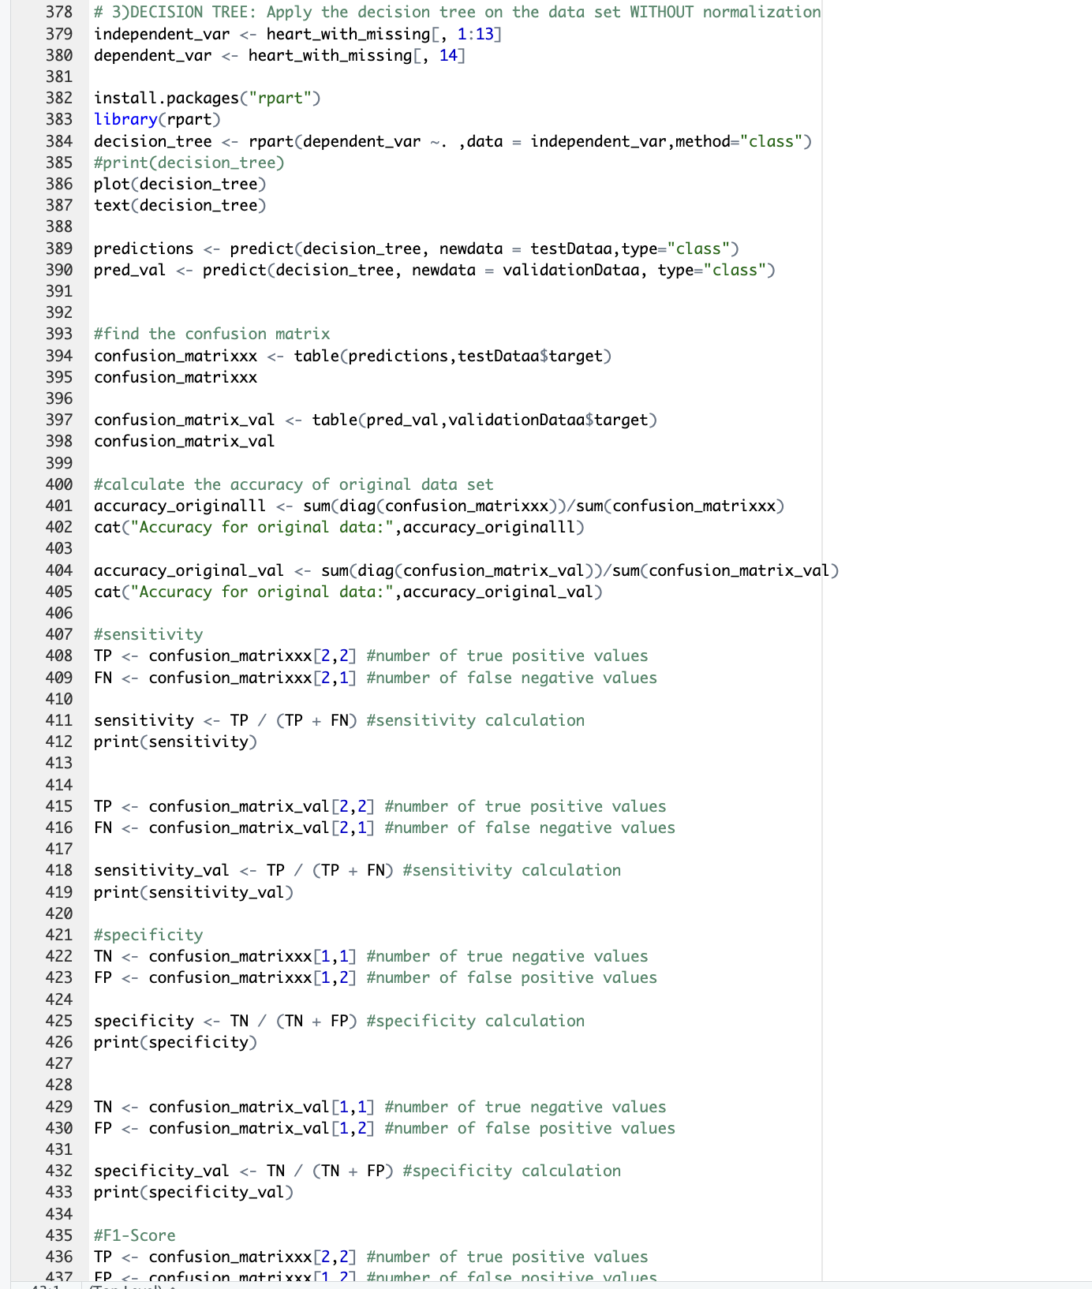

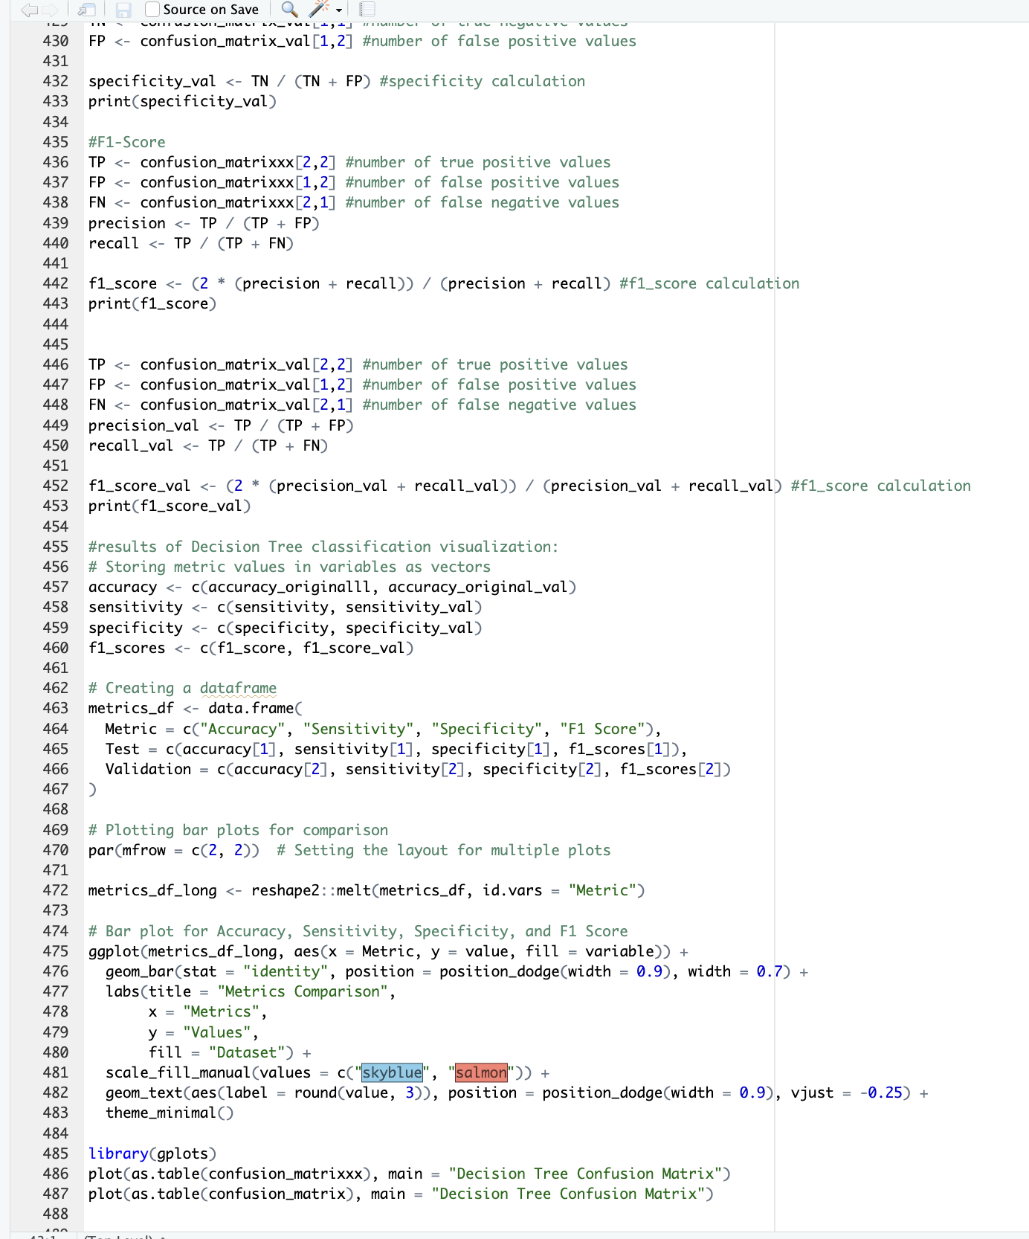

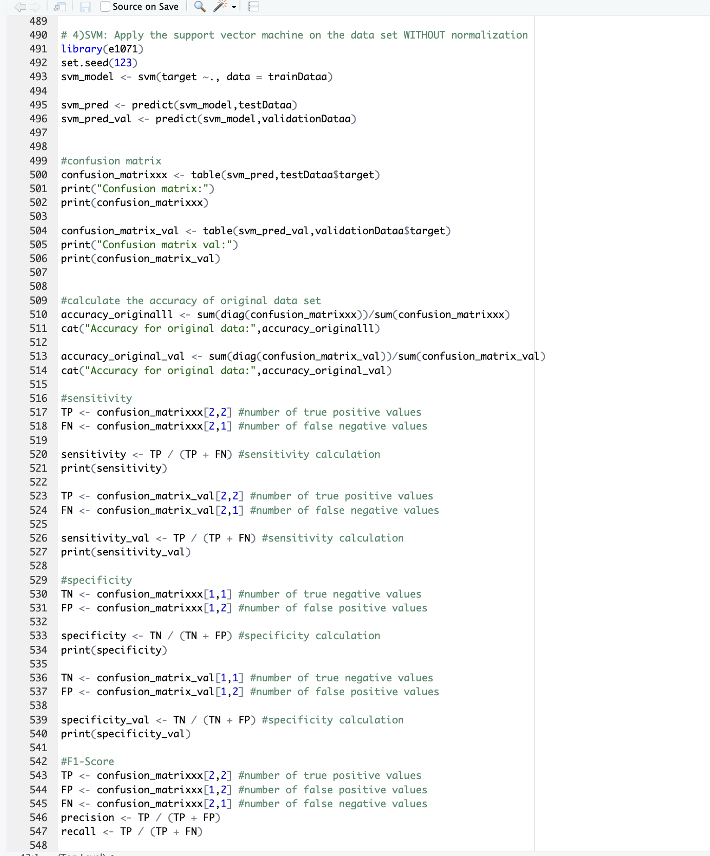

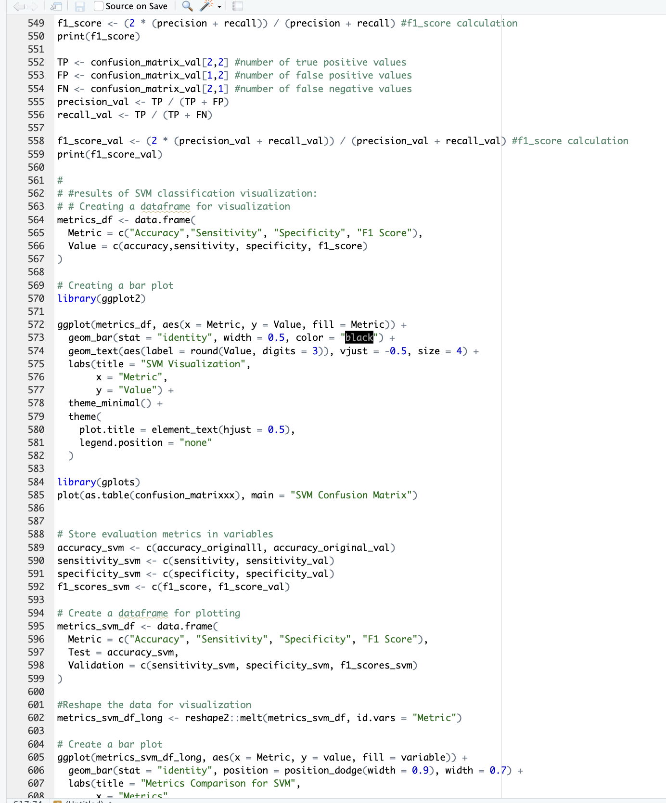

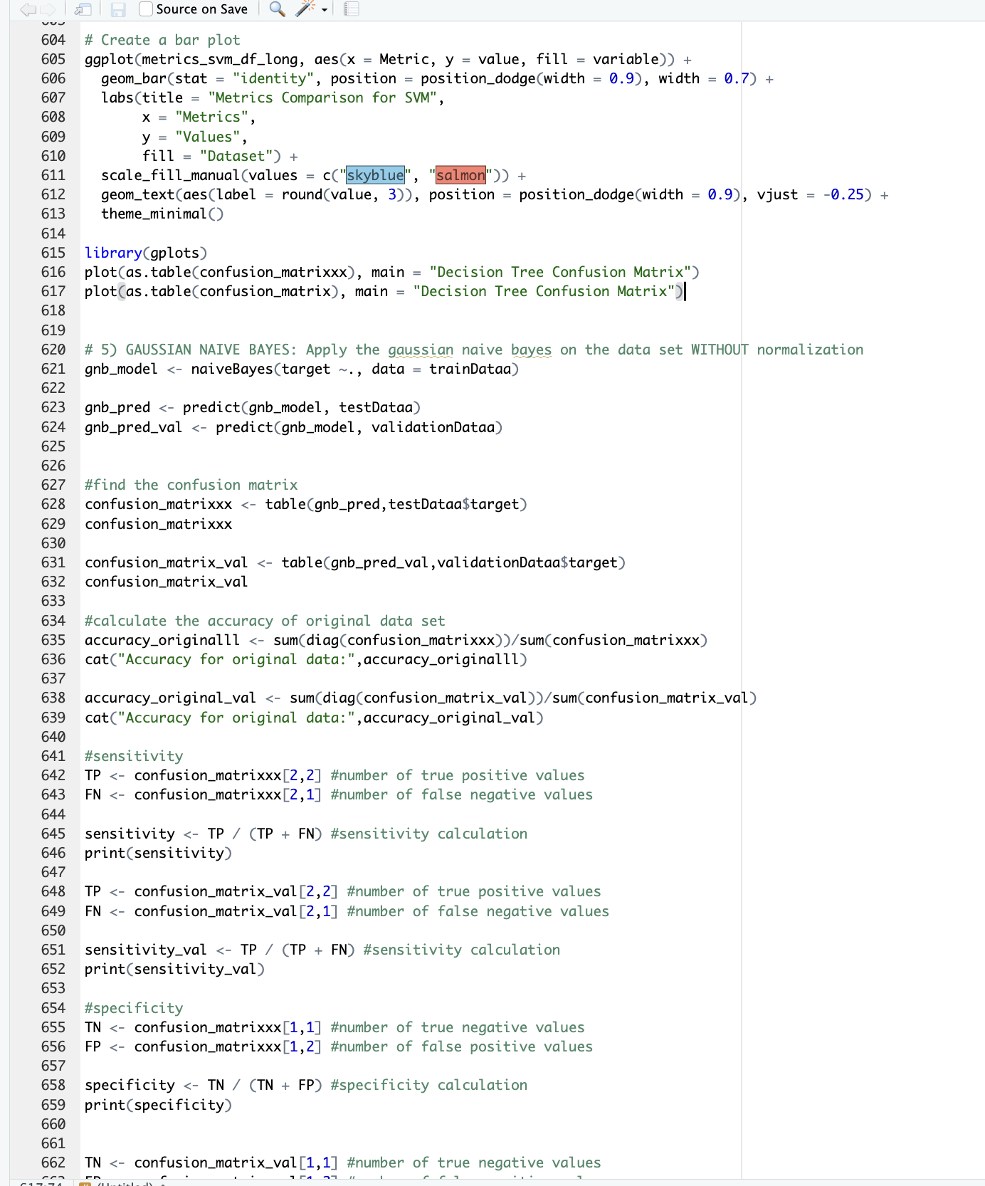

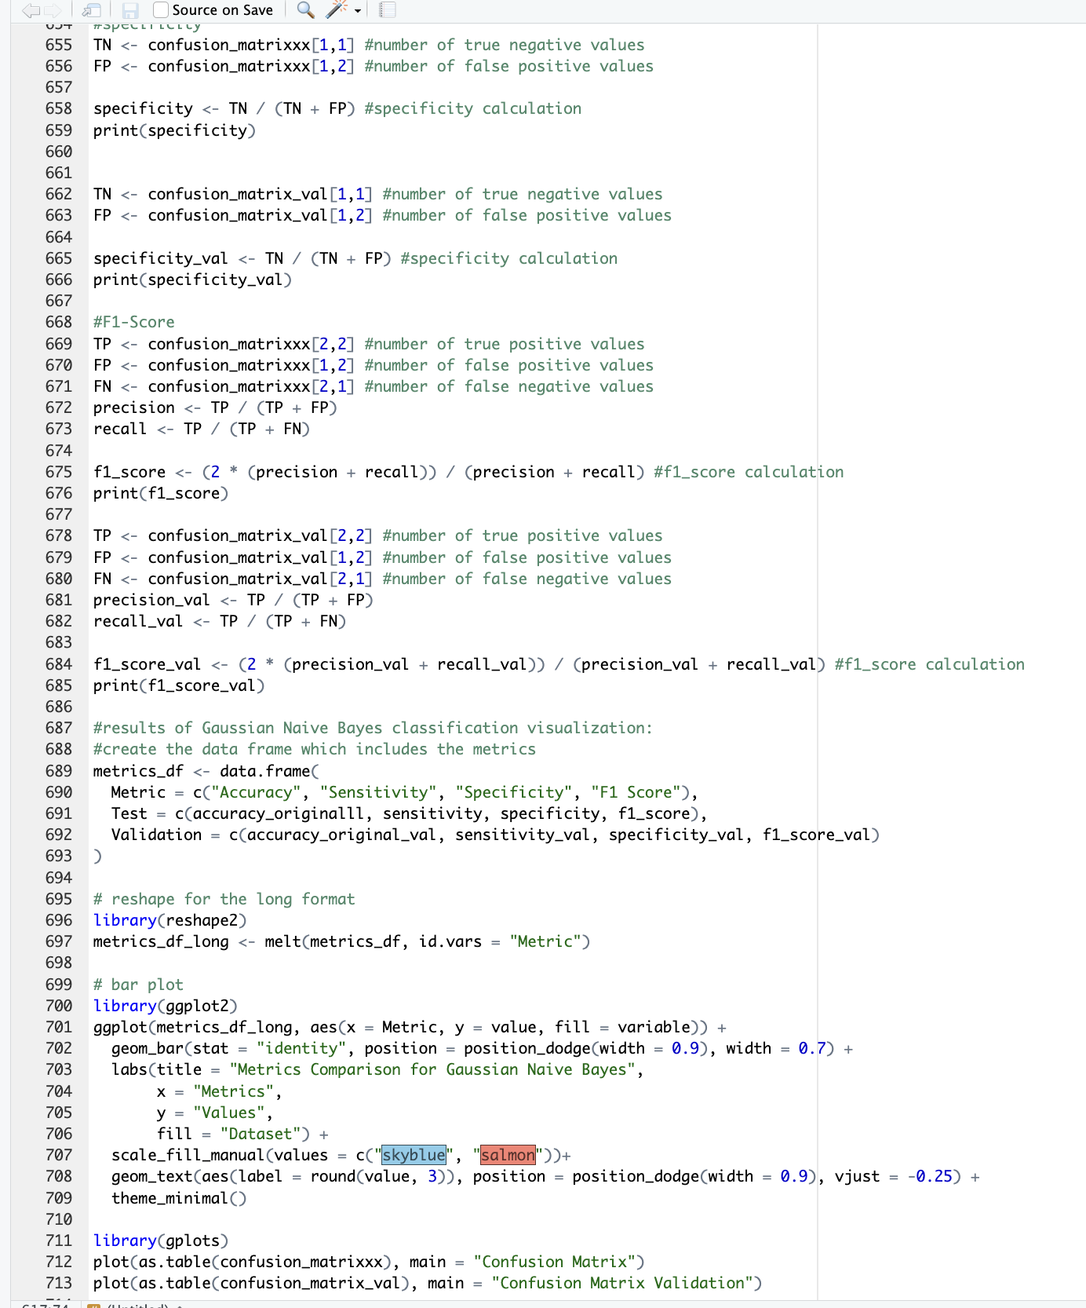

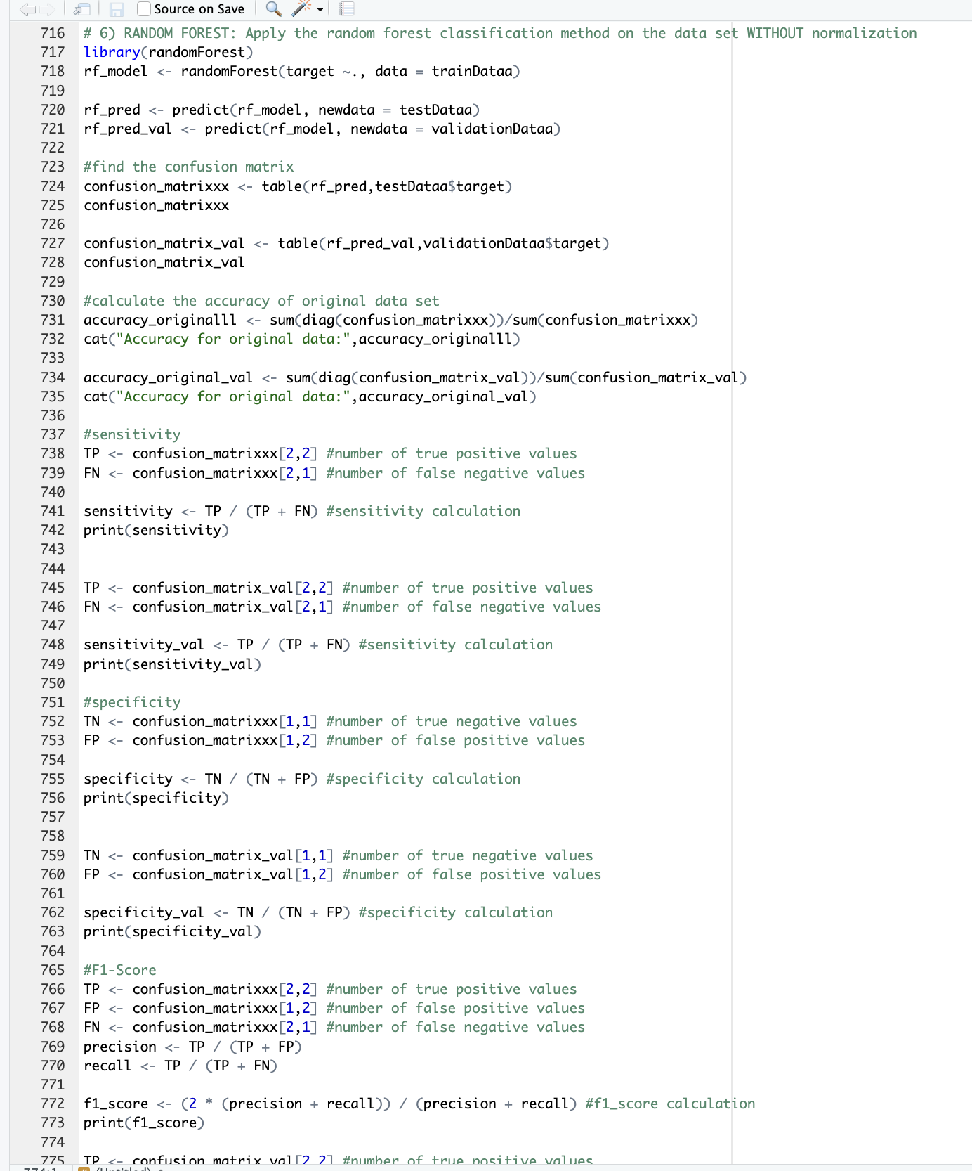

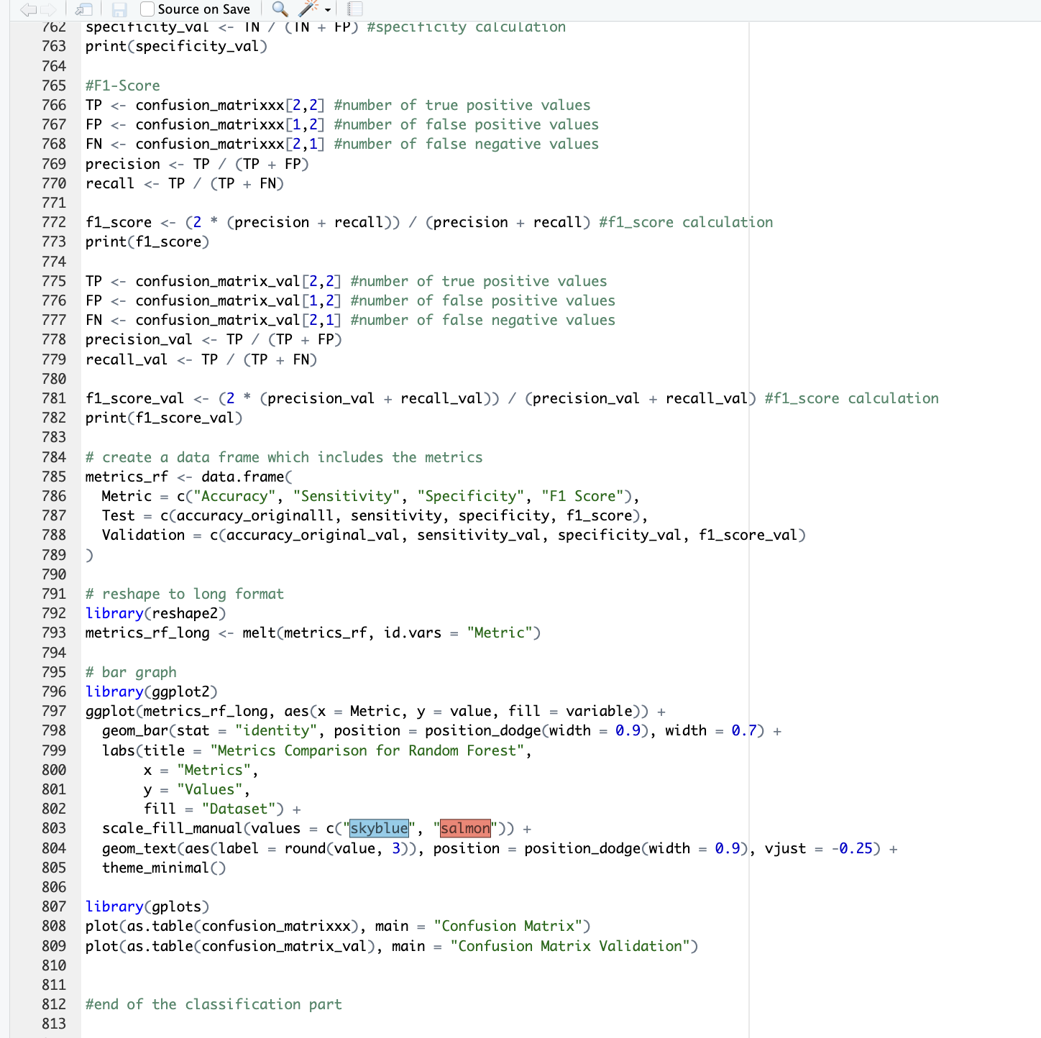

After the classification part I normalized the data with the scale method.

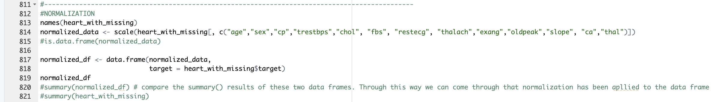

Then, visualized all the normalized data set.

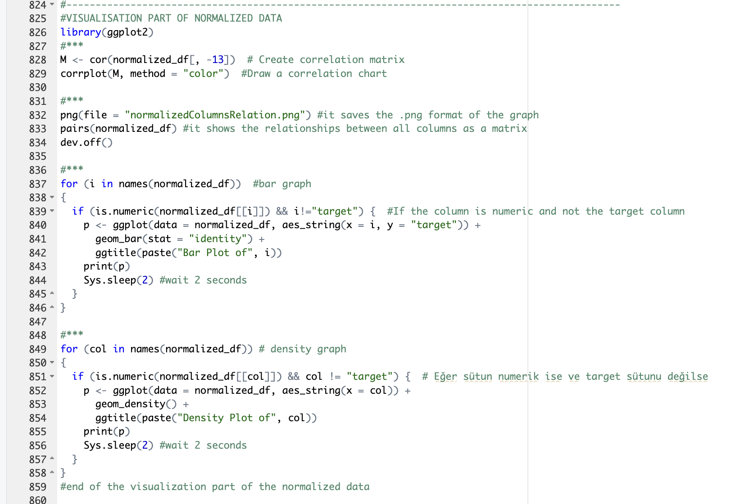

I applied all the classification methos on the normalized data set too.

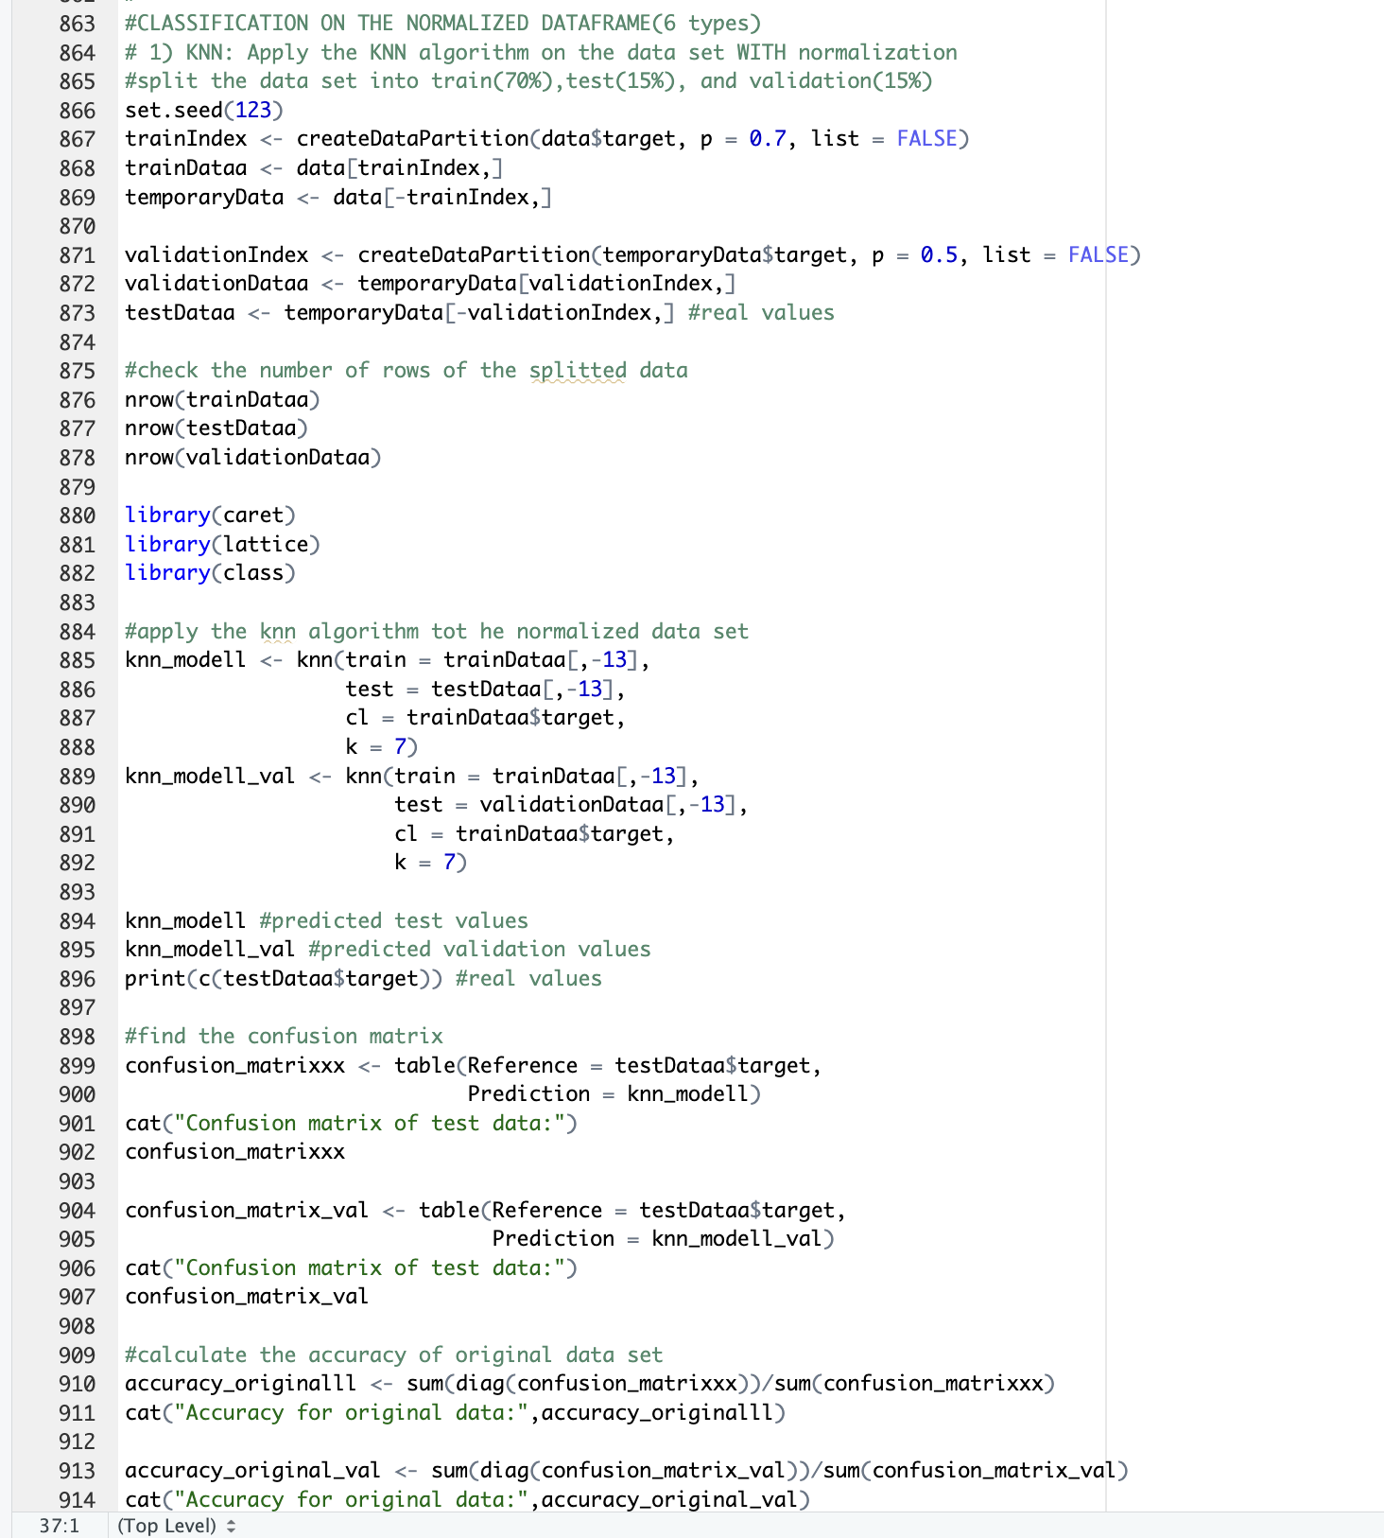

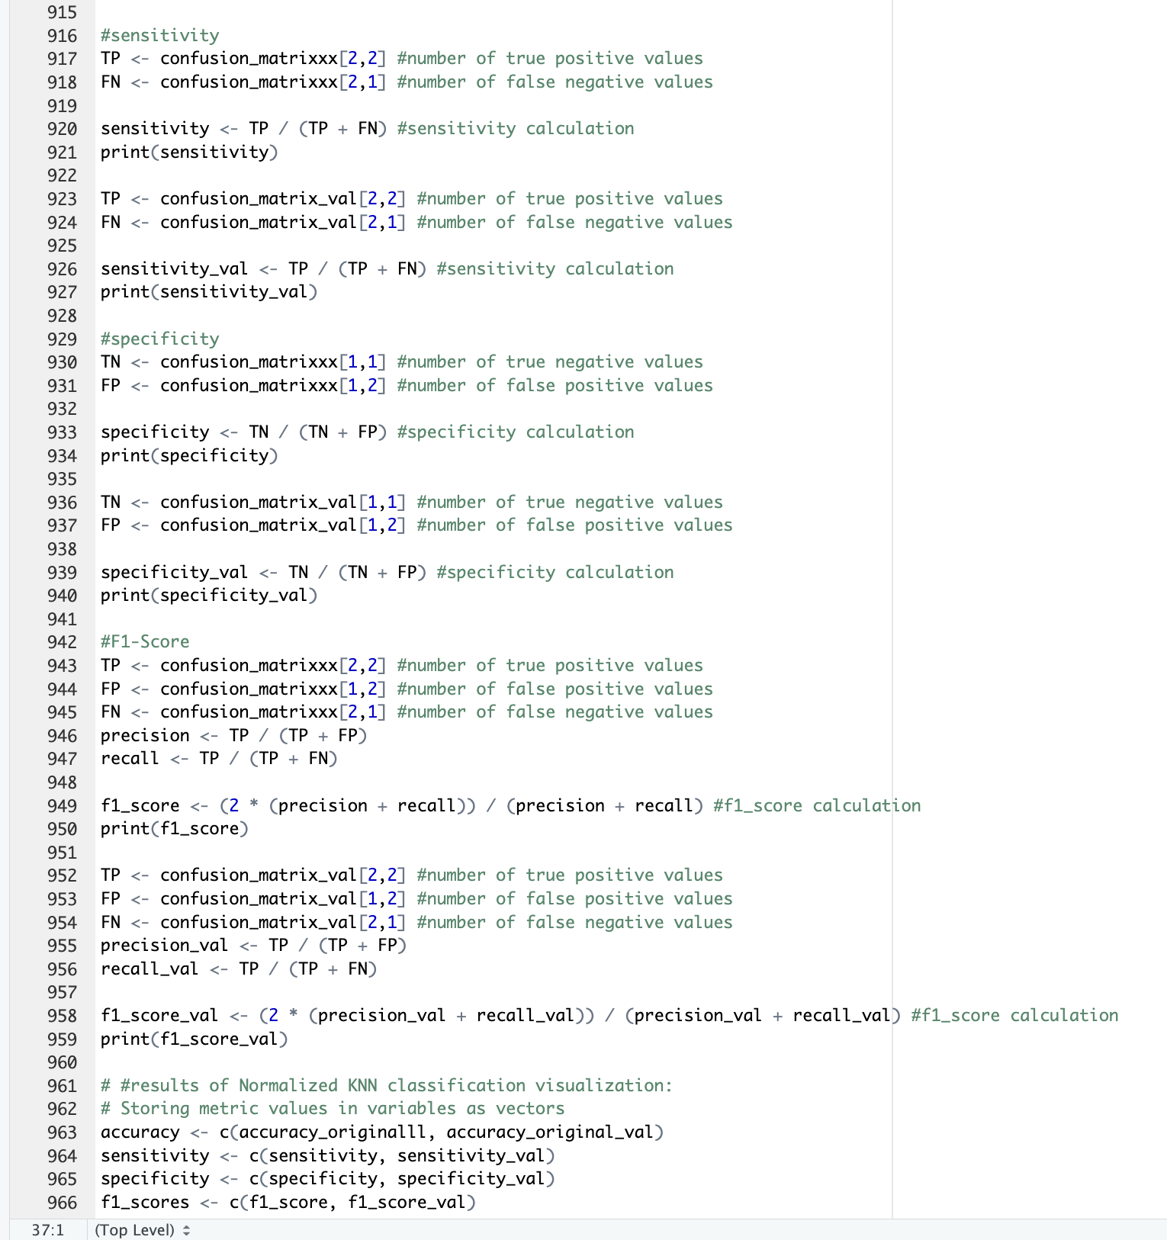

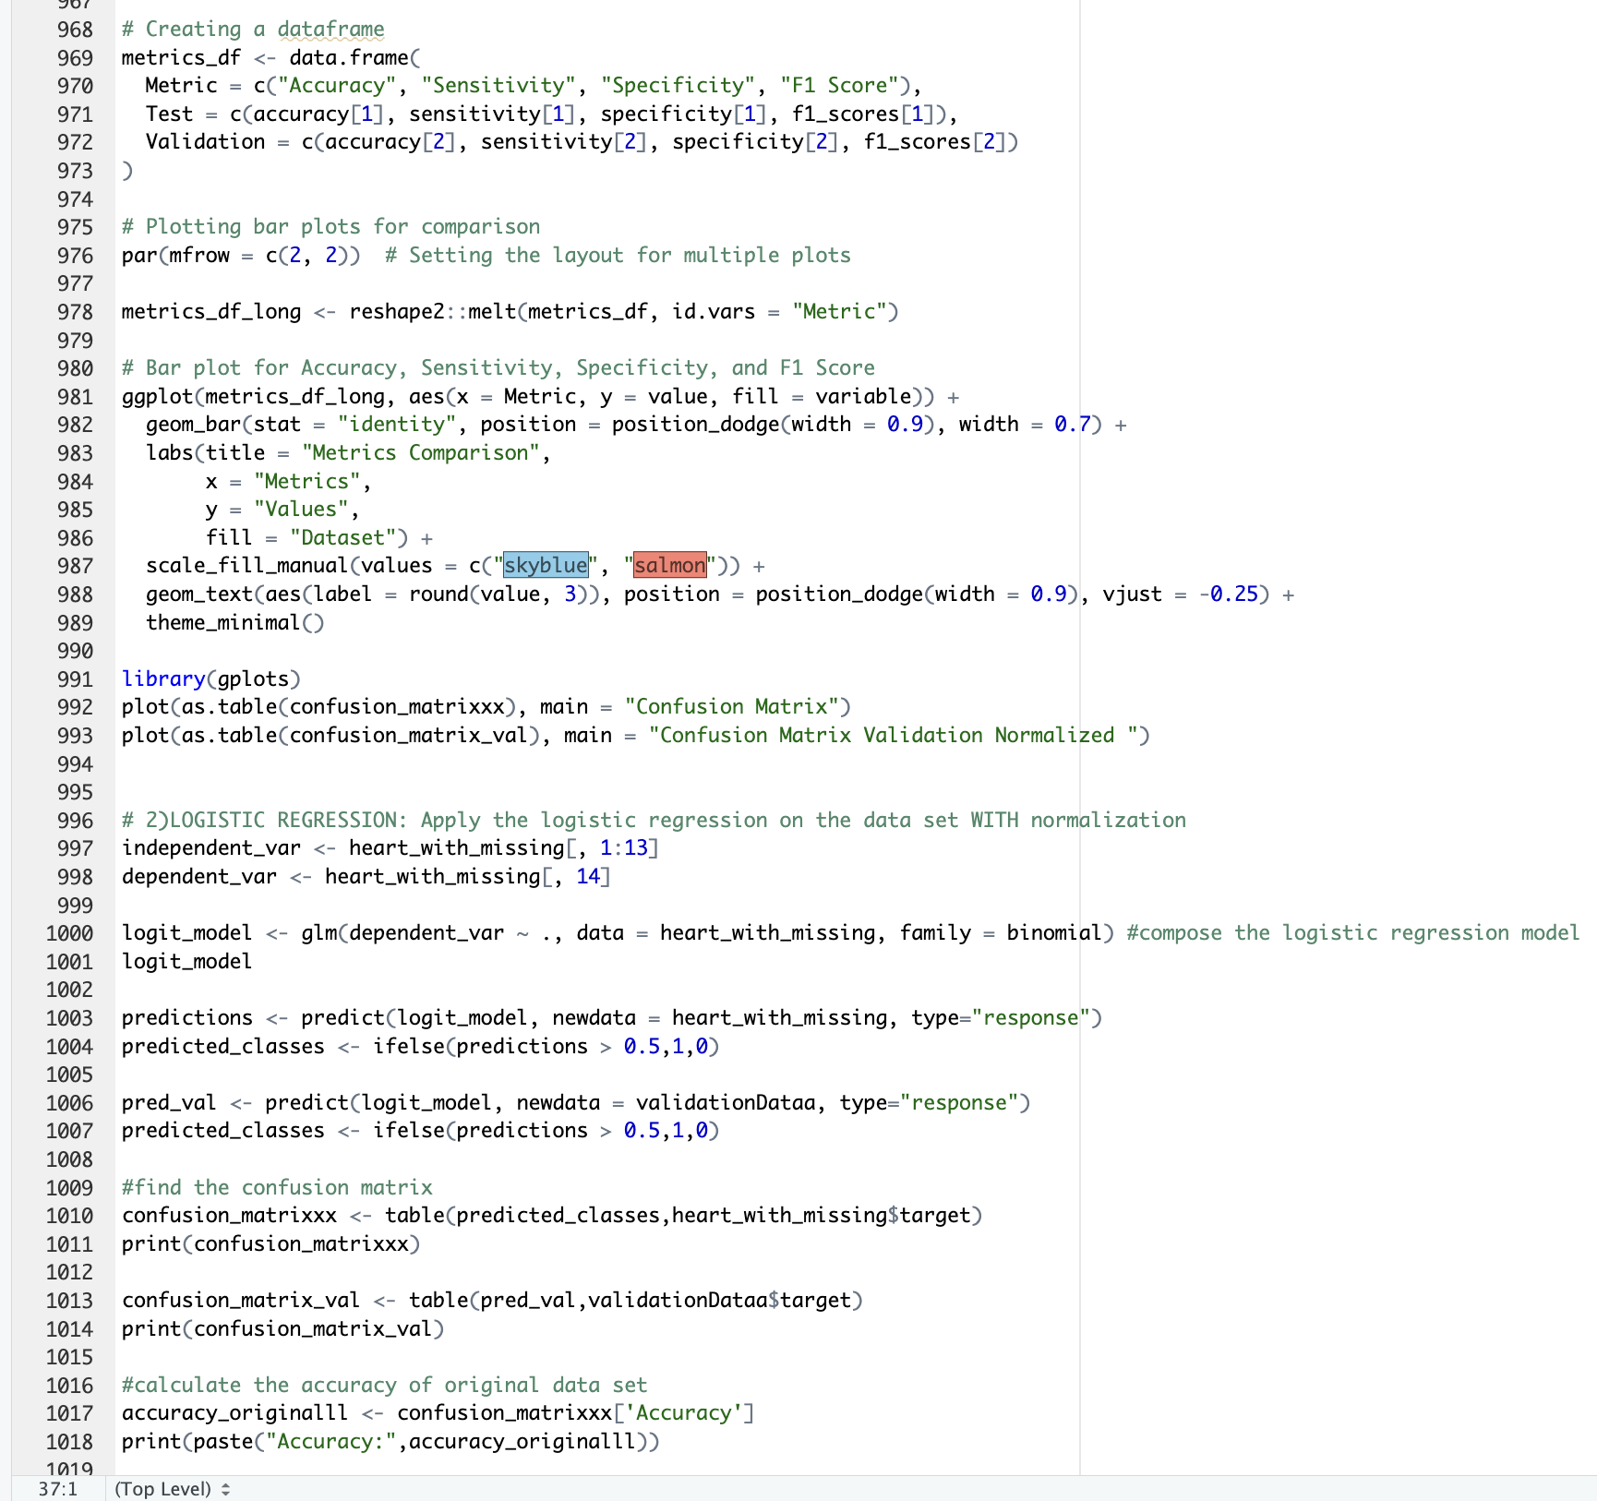

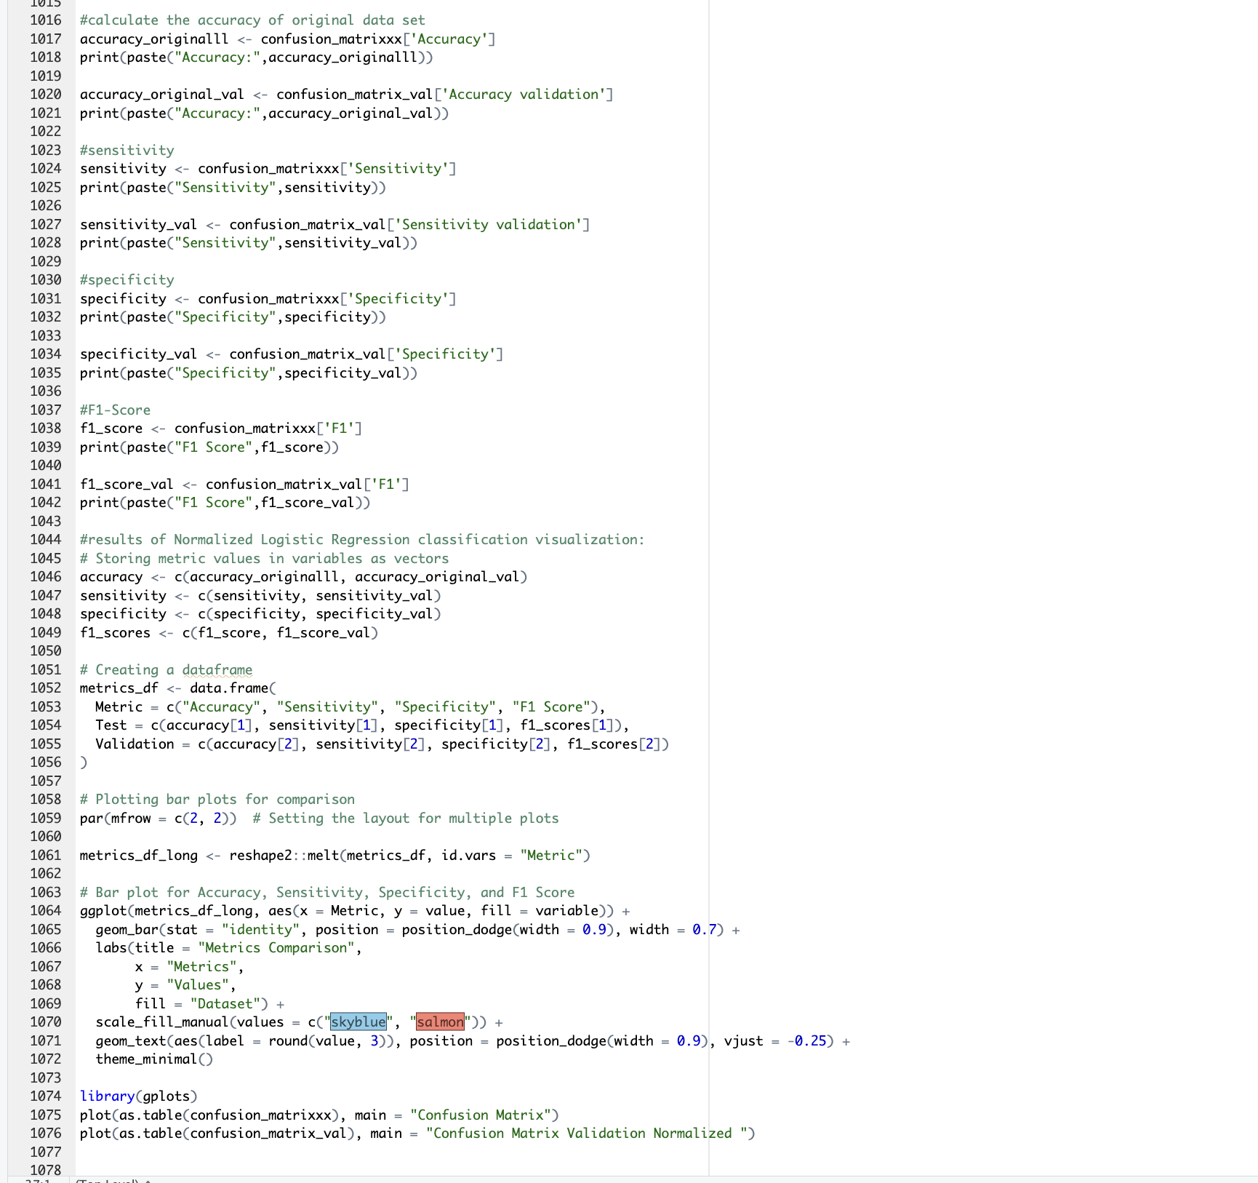

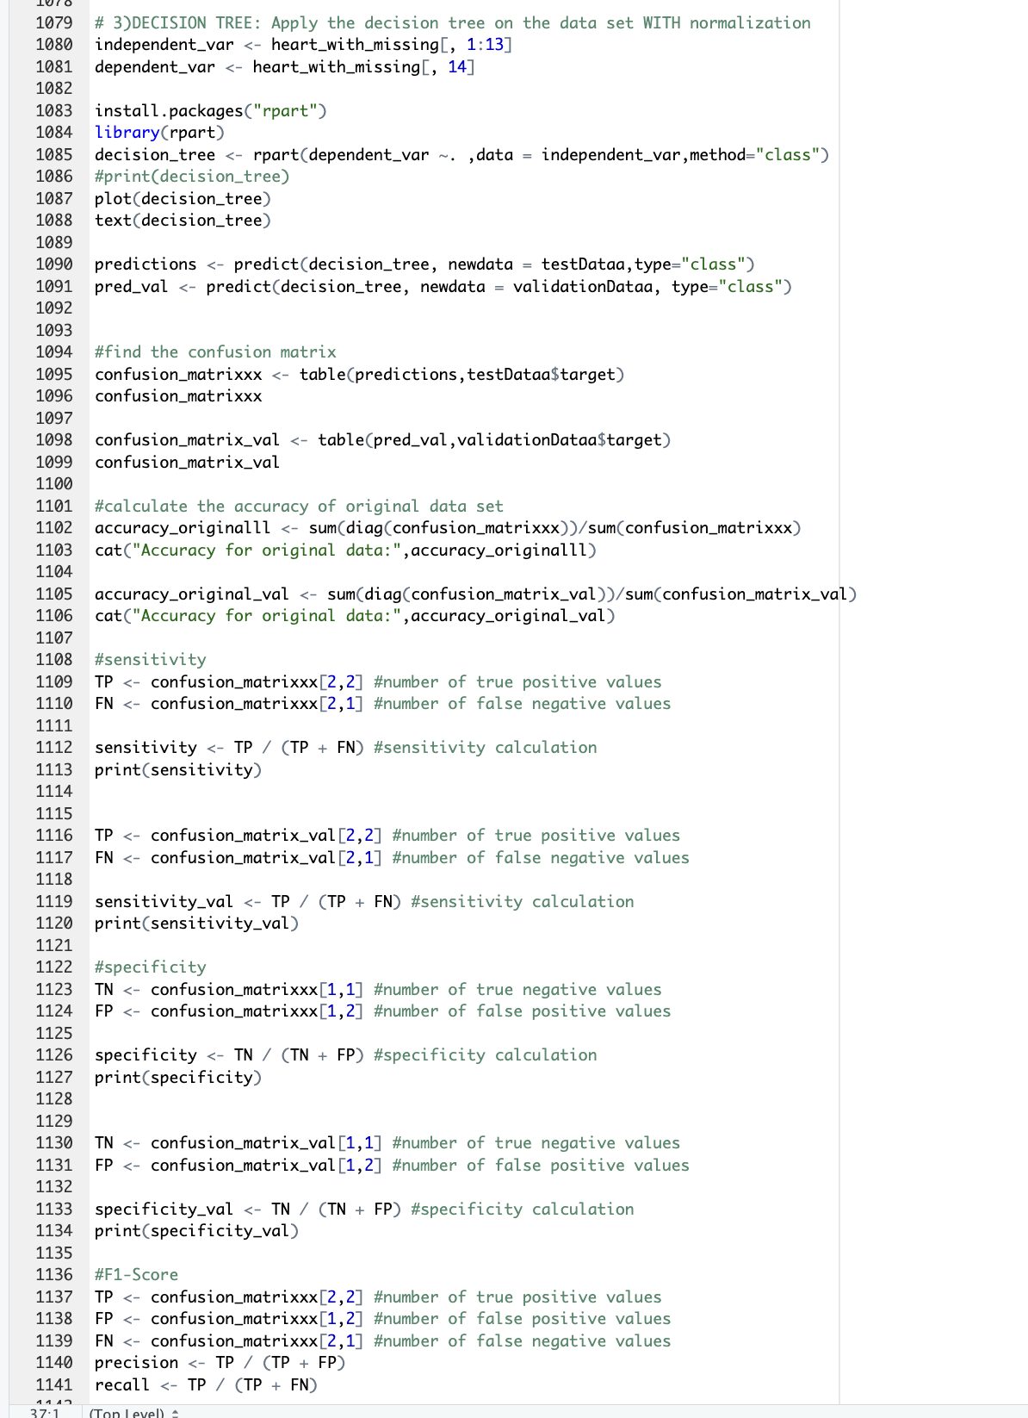

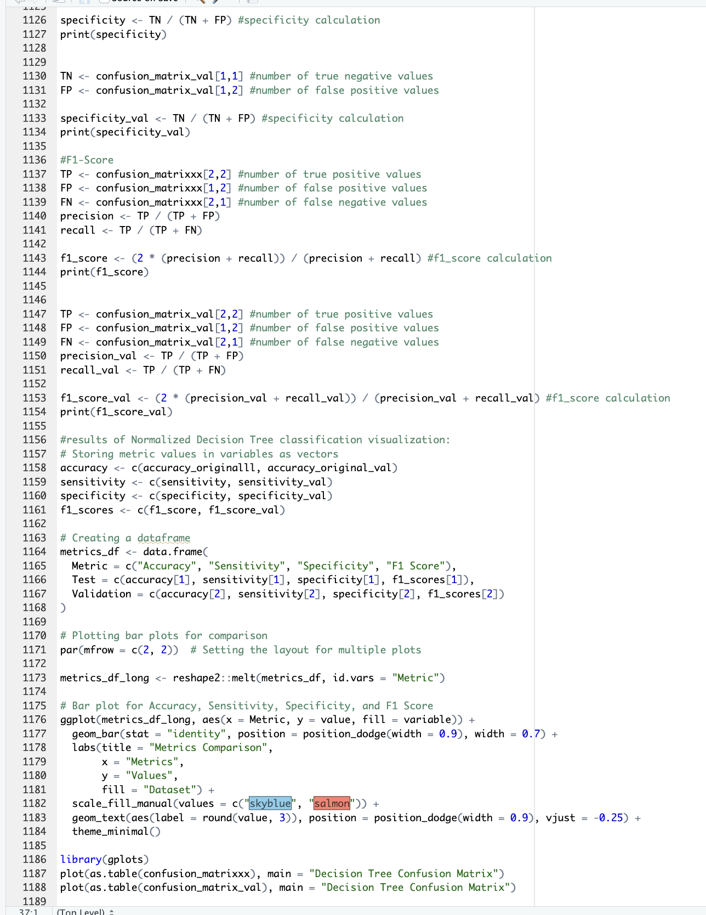

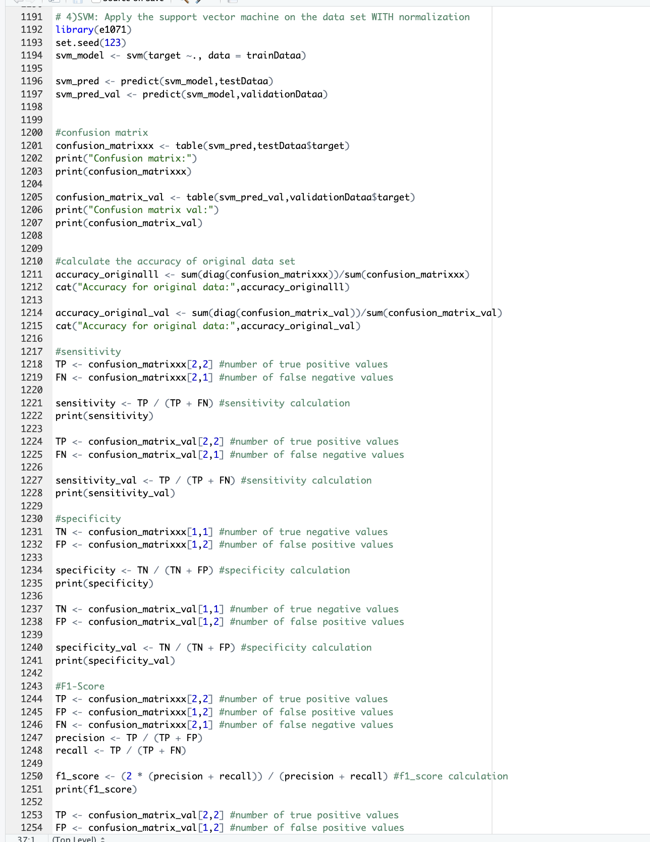

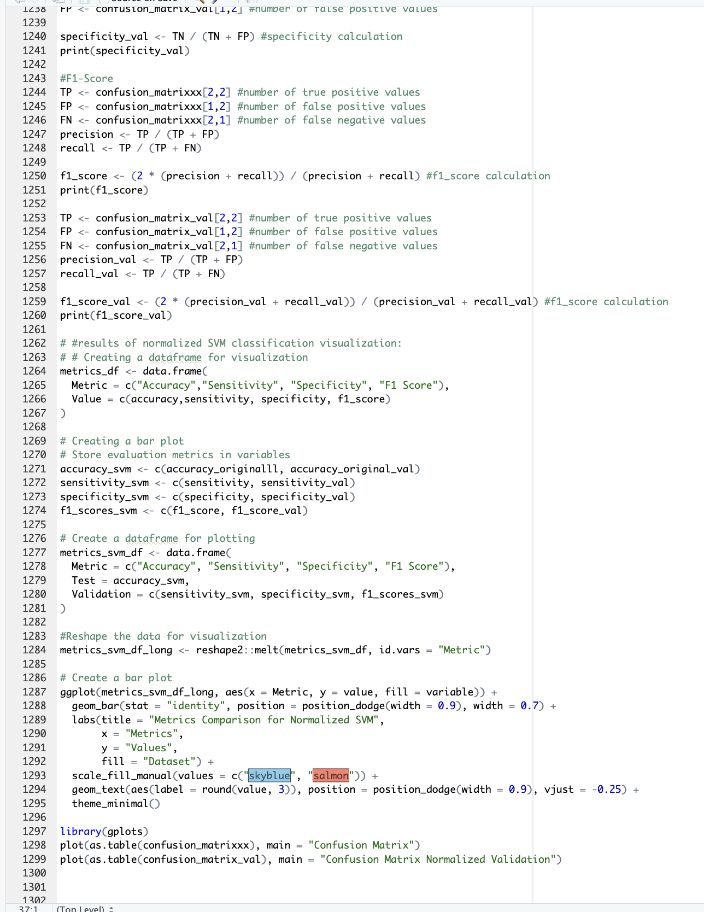

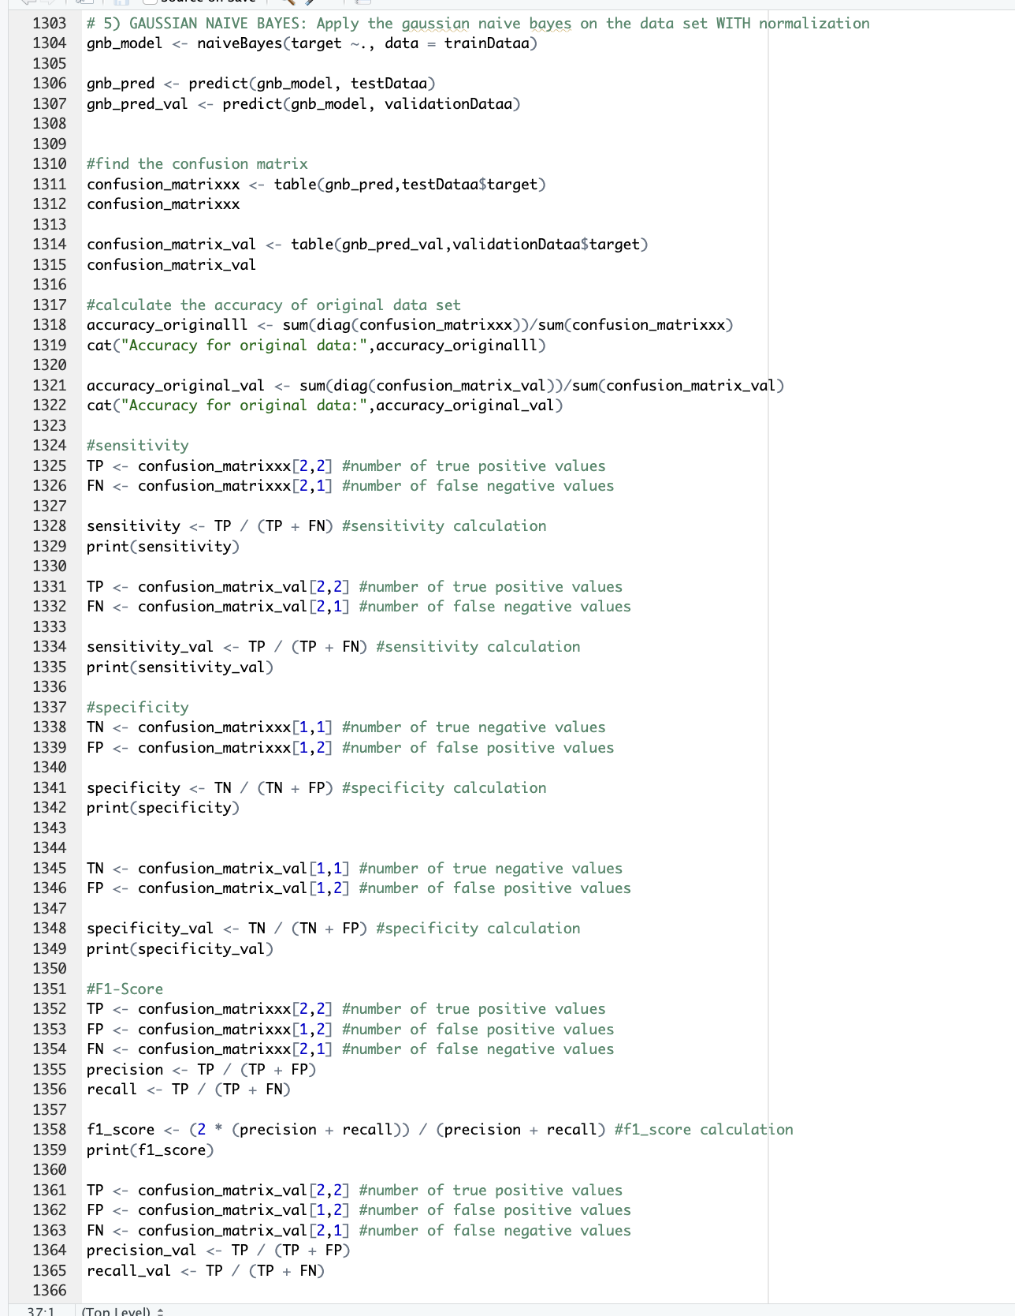

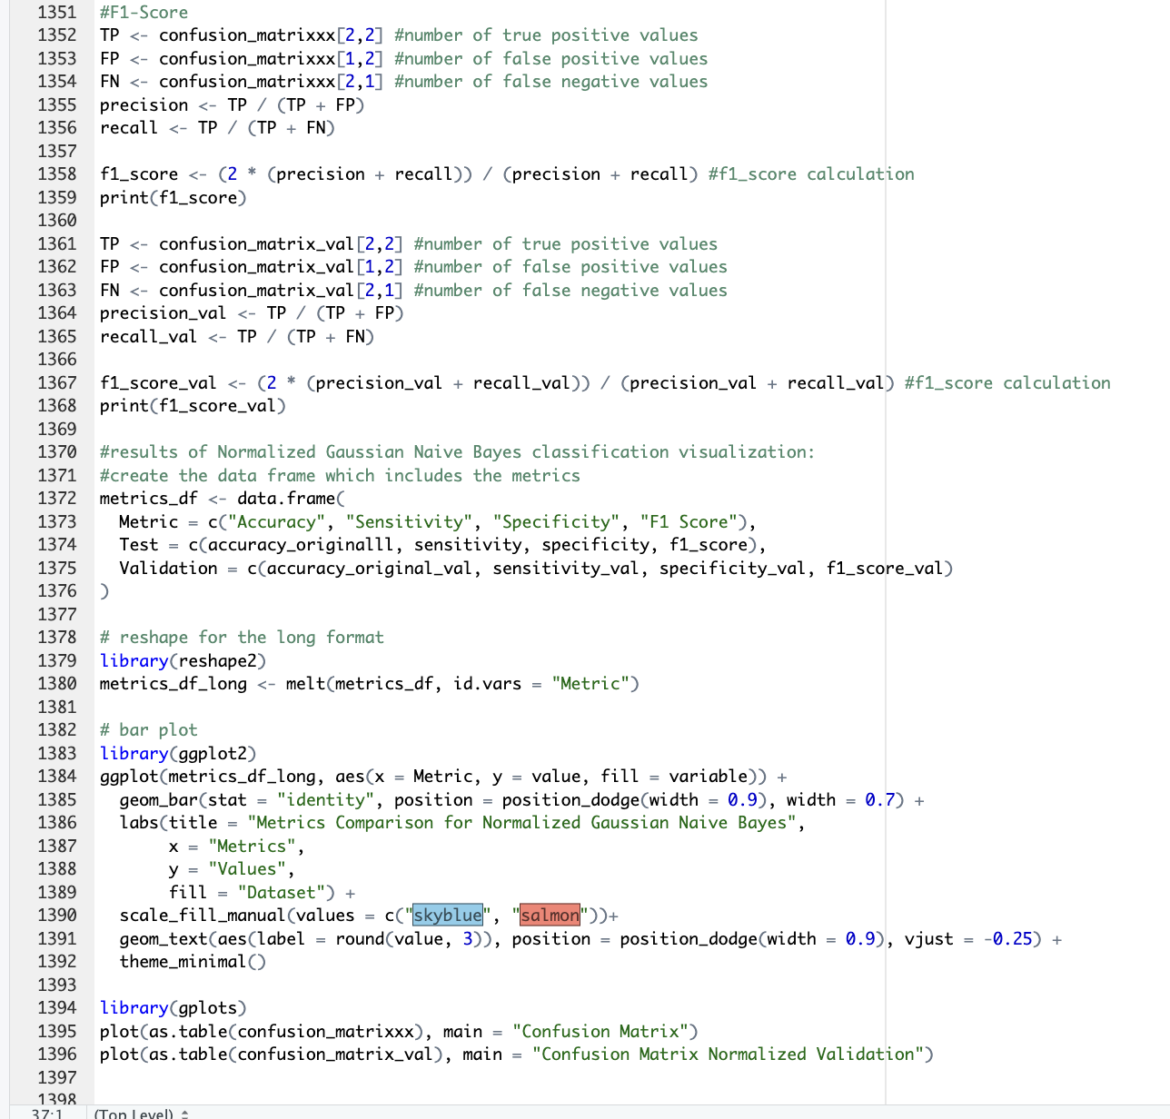

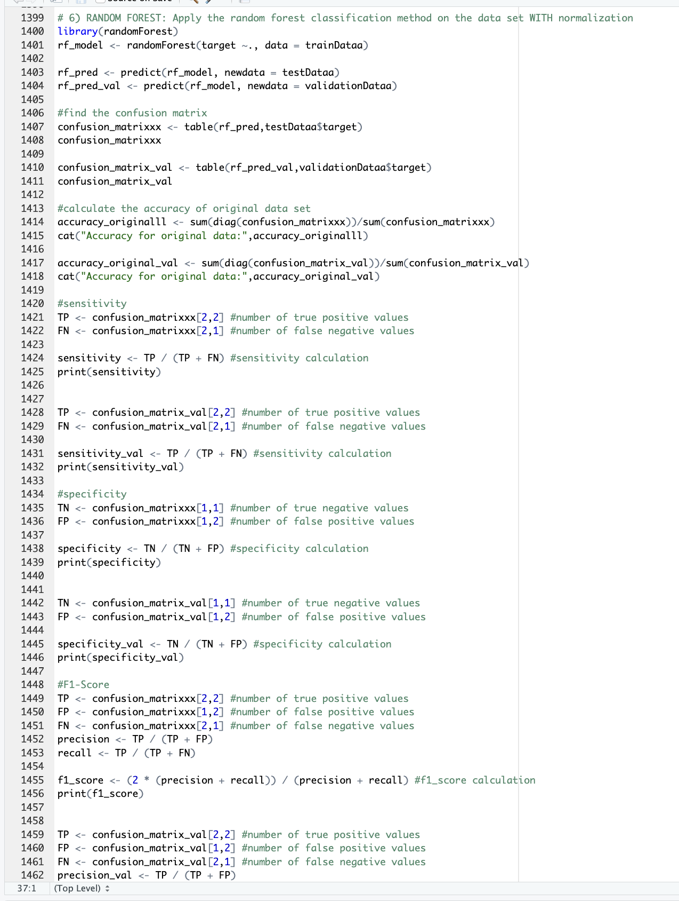

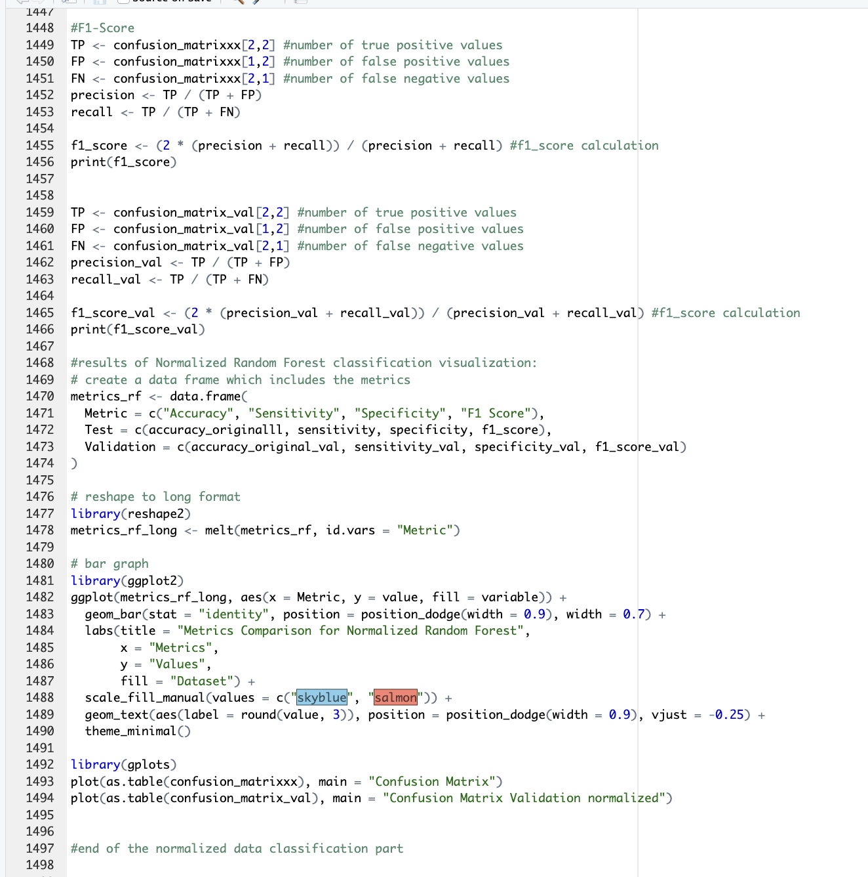

The last step before the best model is feature extraction. I did 4 different types of feature extraction and got the results.

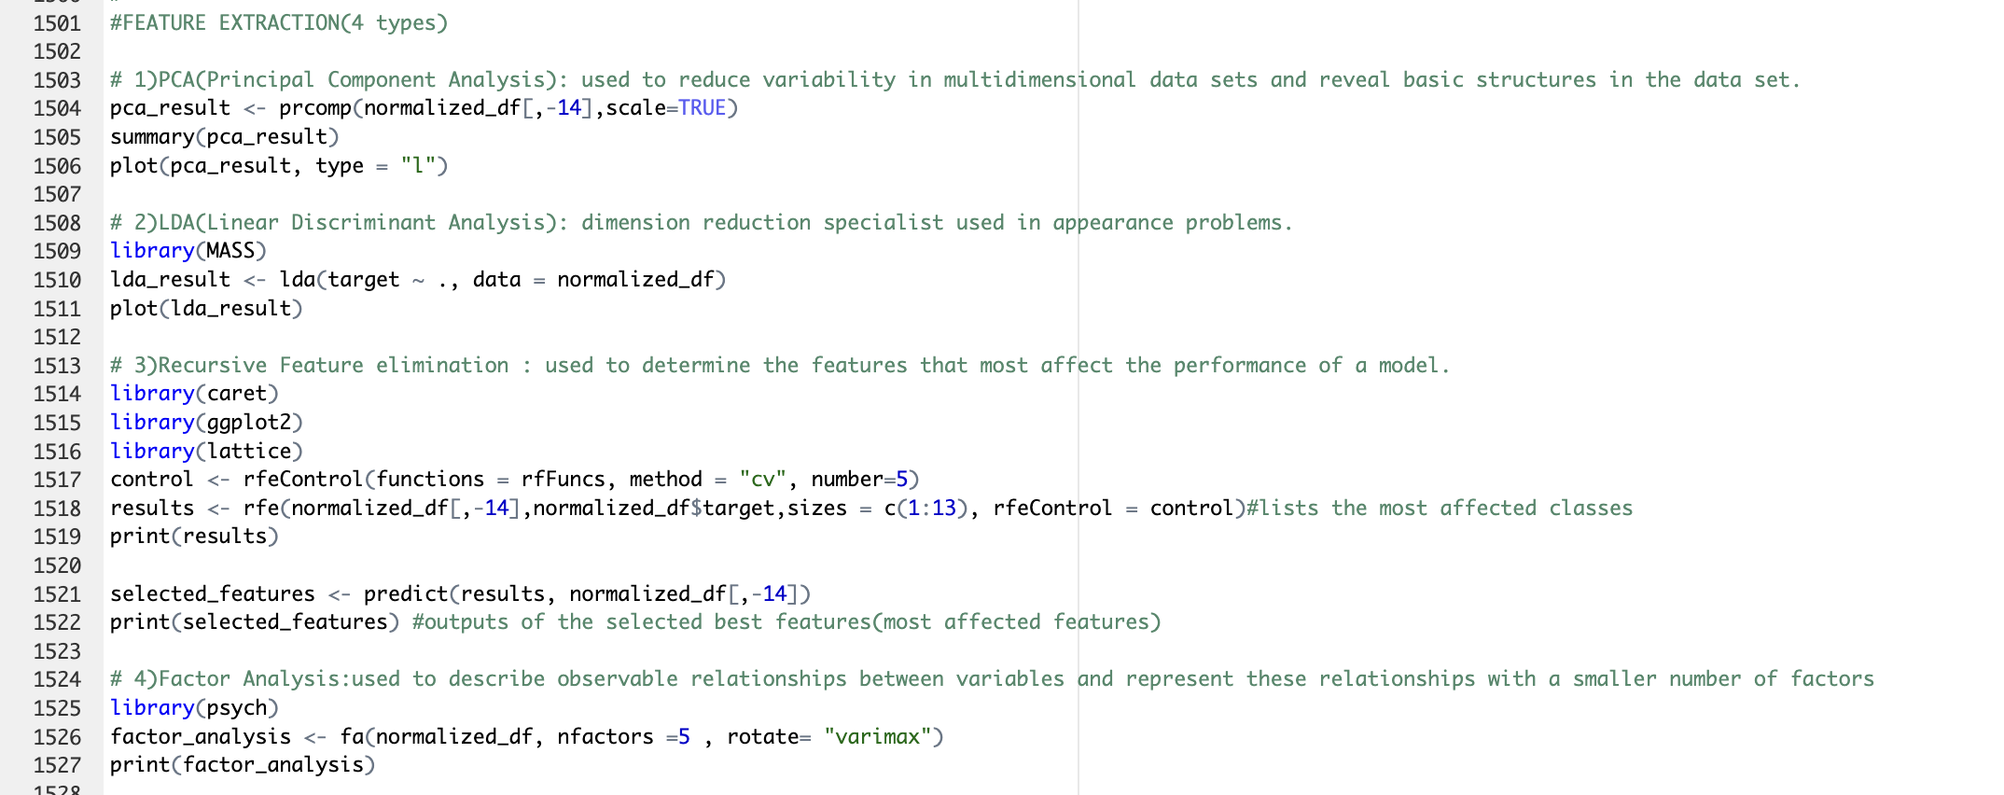

NOTE: All the graphs picture at the folder of “200709001_BetulGuner.zip”.